**Django Python** [Watch Video no. 8 for Git Upload commands]

**Press [windows + Shift + S] to take screenshot in Windows**

* Make the project folder in **Desktop** as **"carzone-project"**
* Go in this folder location & press "Git bash" to open CMD

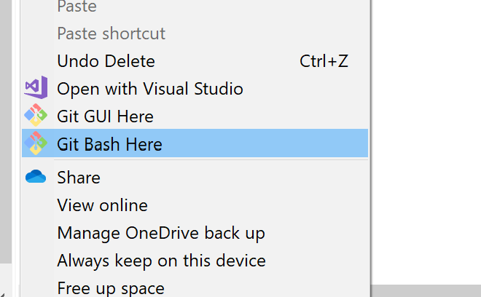

* CMD:

pip freeze

python -m venv env

source env/Scripts/activate

....

....

deactivate

pip install django==3.0.7

python -m pip install --upgrade pip

django-admin startproject carzone . #creating Django project now: it will create project folder & a **manage.py** file

python manage.py runserver #trying to run django server first

* type ip address in browser: 127.0.0.1:8000
* So, as we created a django project, next step is to create a Django app, we can have multiple apps inside 1 project. In our project we will be creating 3-4 apps, the first one will be "pages" for our "contacts-services-information" pages. After that, "cars", "contacts", and "accounts" apps for login functionality.
* Creating "pages" app

go to git bash window & stop server with "ctrl+C"

Make sure you are in Virtual environment

* python manage.py startapp pages # to create "pages" app
* Just after creating an app, go to "settings.py" file in "carzone" named folder in "Atom"

Now, add newly created app "**pages**" in INSTALLED_APPS=['**pages.apps.PagesConfig'**]

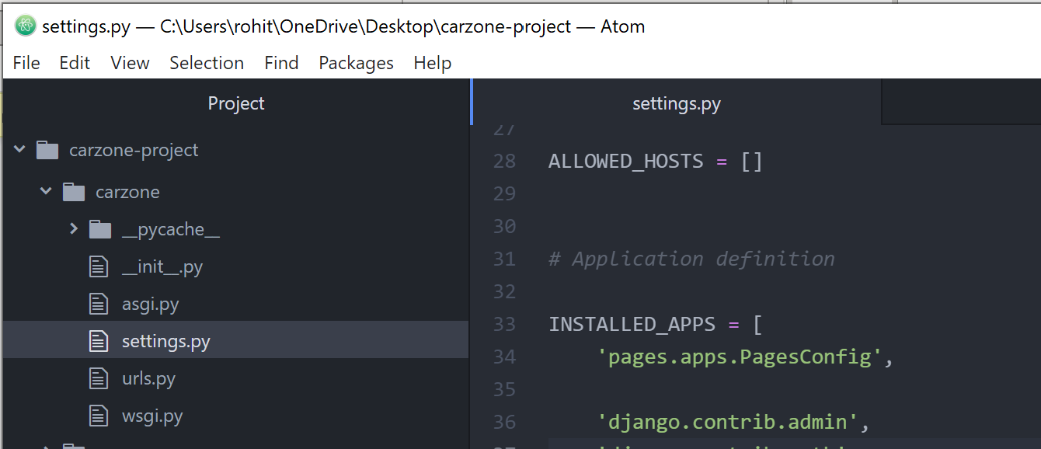

Here, **PagesConfig** is the **ClassName** of our recently created **pages** app

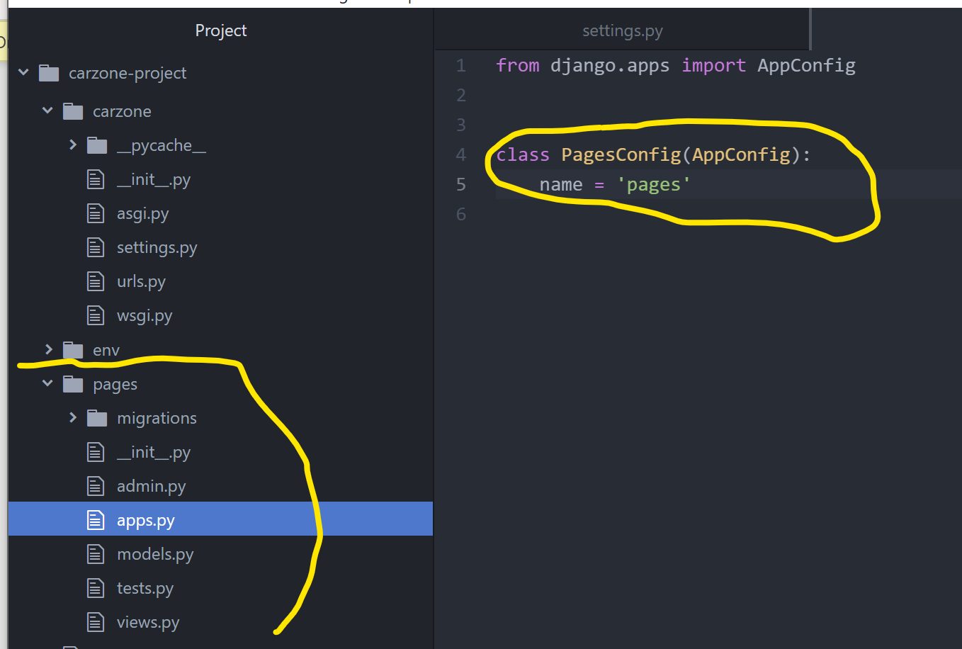

* Now, we will make the URLs

As we do not get any **urls.py** inside **pages** folder, so we will create one now

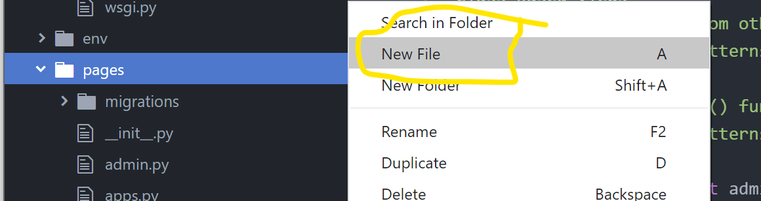

* Now, we will create our **Home page**

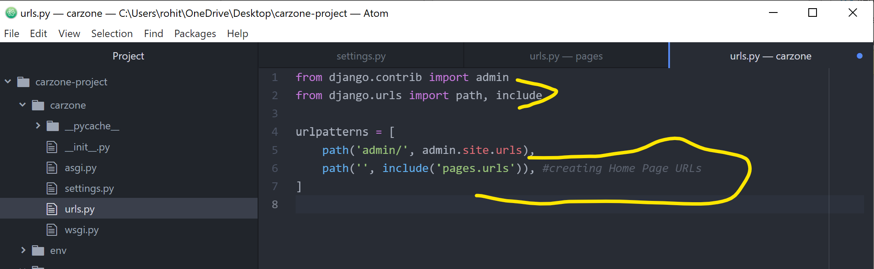

What it does is: when someone comes/requests to the Homepage (‘’ means Homepage), the control will go to **pages app** & inside this app **urls.py** file will be called.

* Now, we have to configure the HomePage functionality in **pages🡪urls.py** file

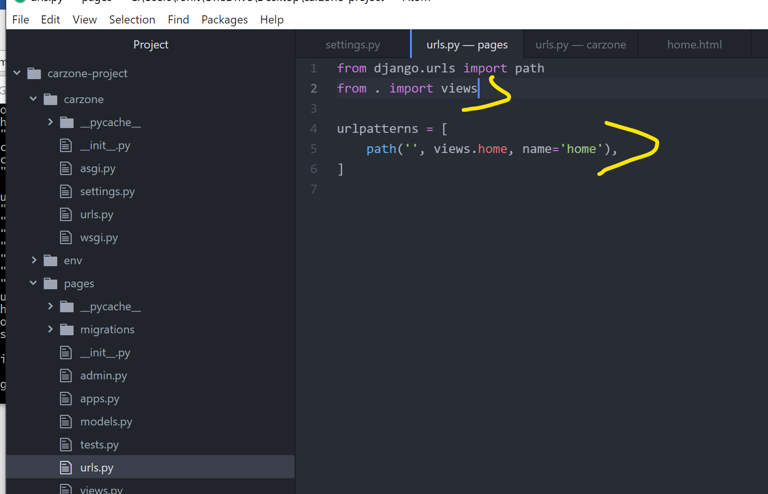

* Now, we have to create a view named as **home** in **pages🡪views.py**

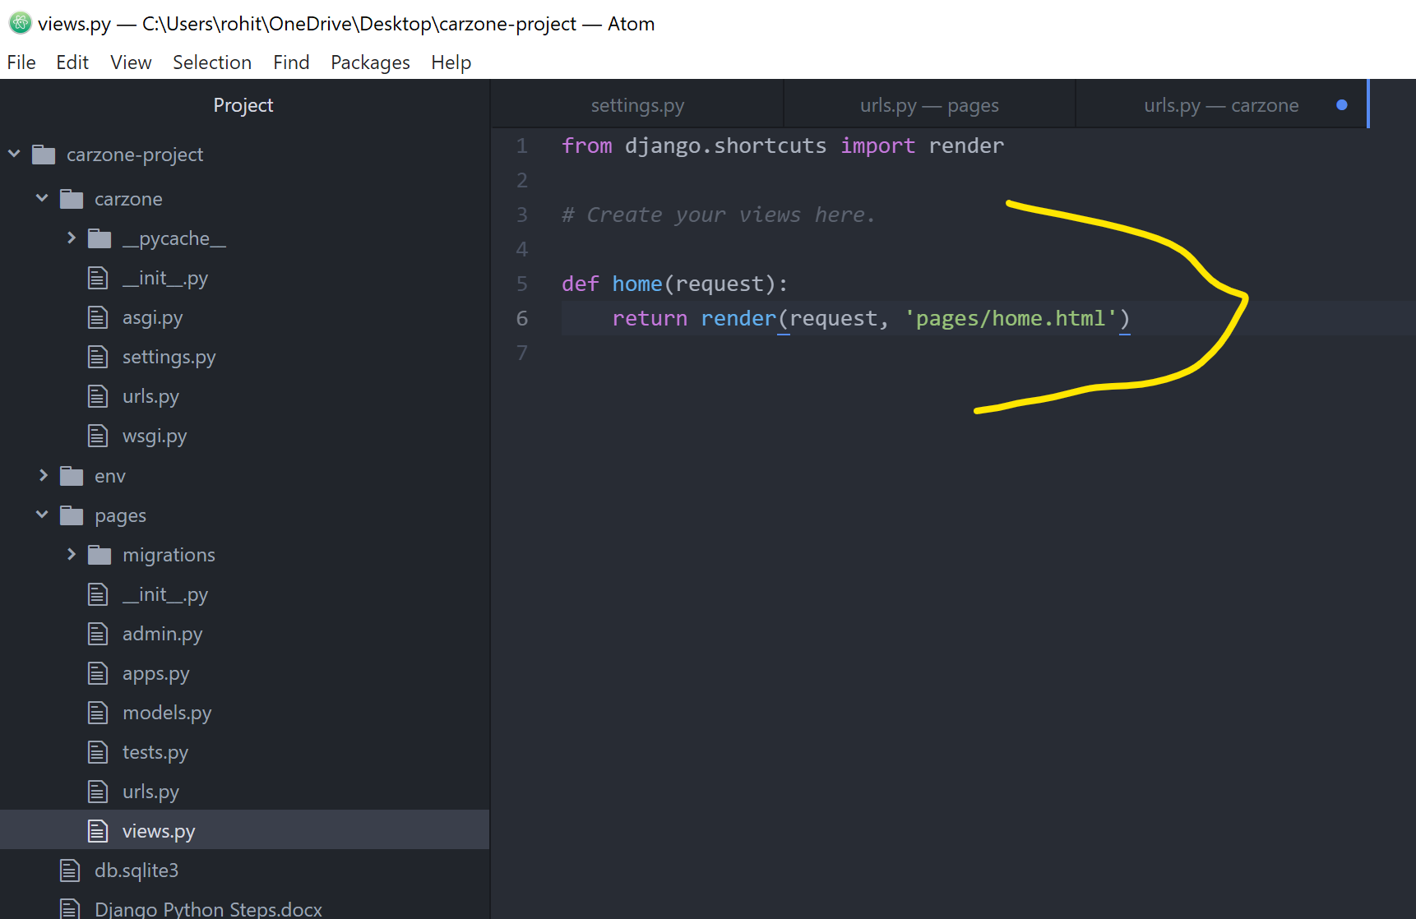

Now, we have to create this **pages** folder & **home.html** file, so we will create that.

But before this we need to create a template.

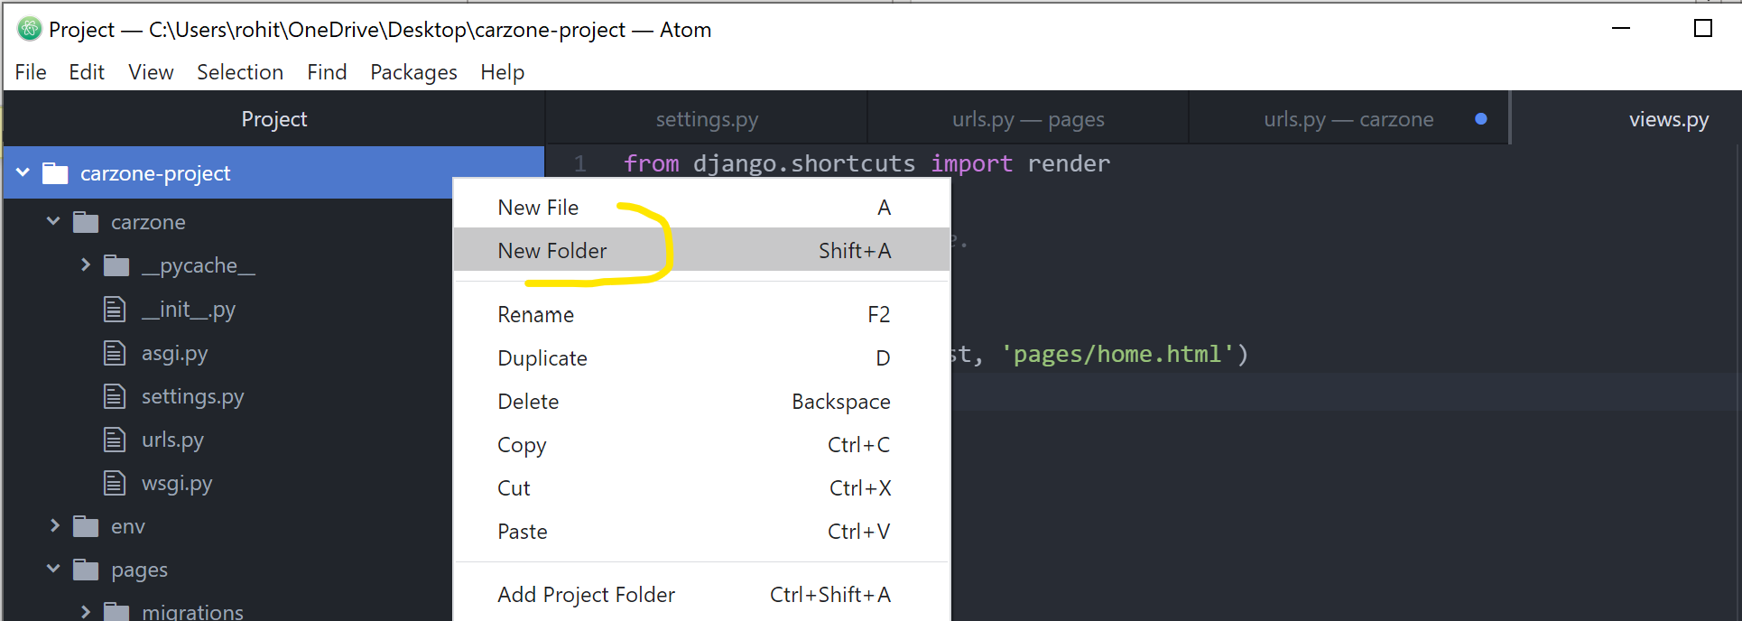

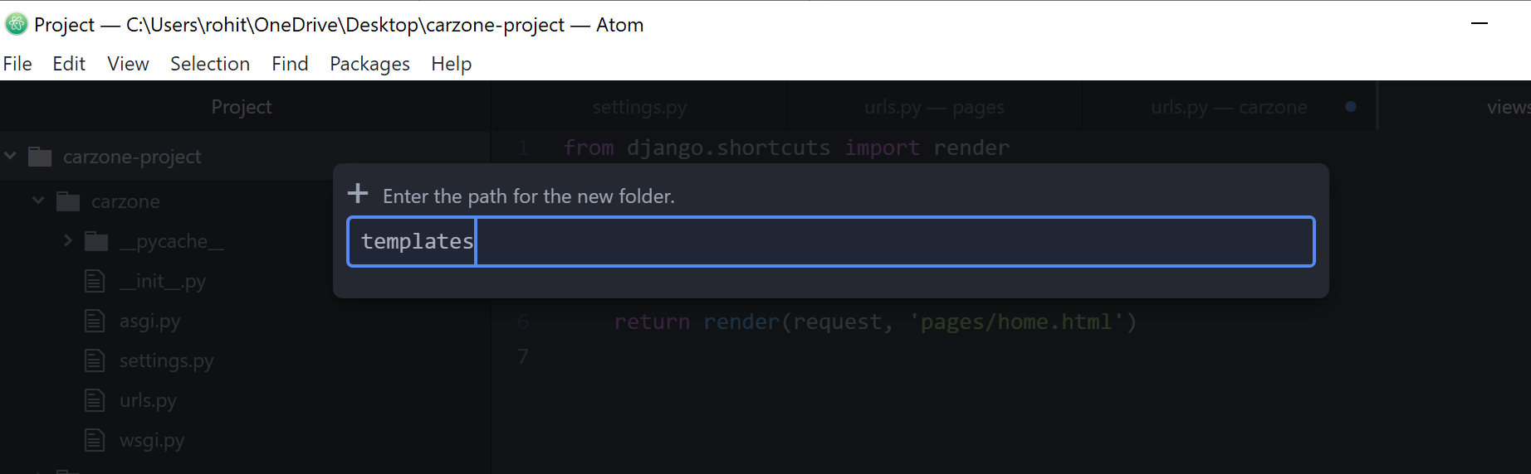

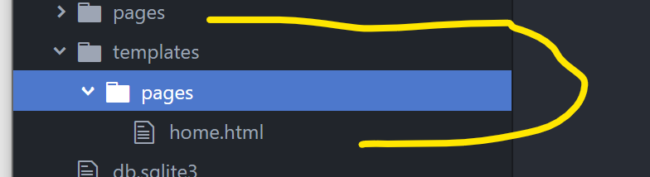

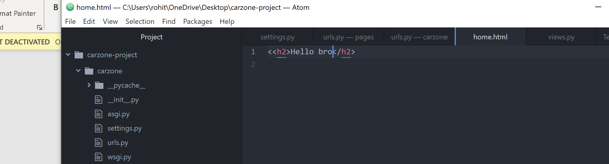

As we created **templates** folder, we have to tell the **settings.py** file that we created the **templates** folder.

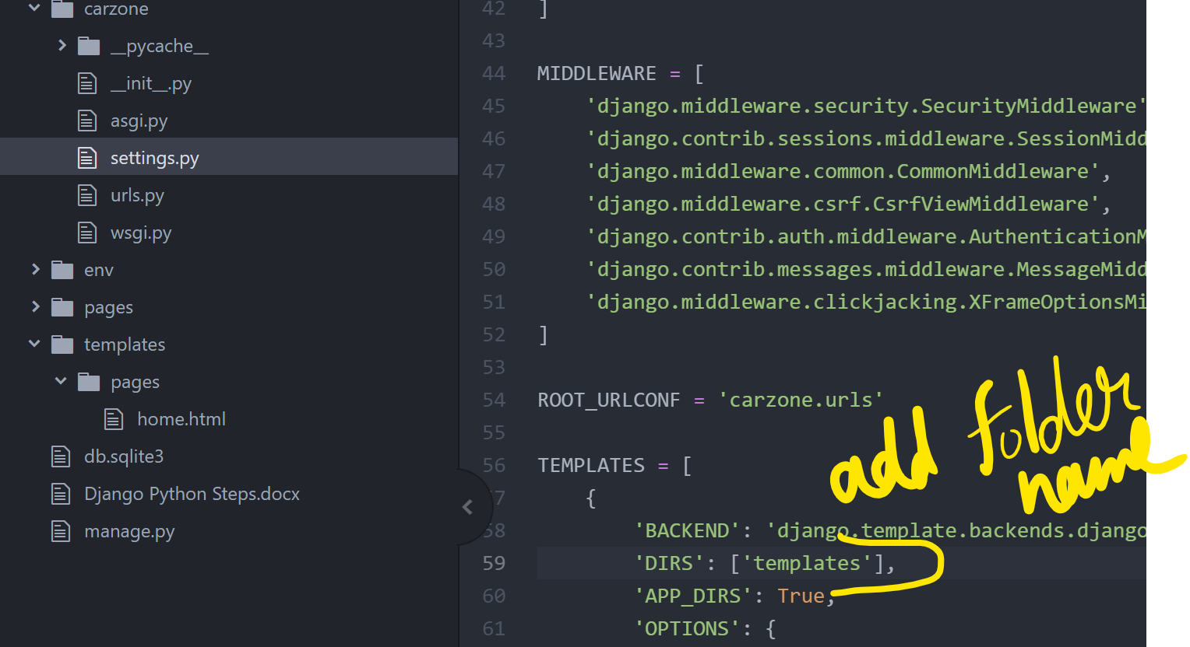

* Start the server now

python manage.py runserver

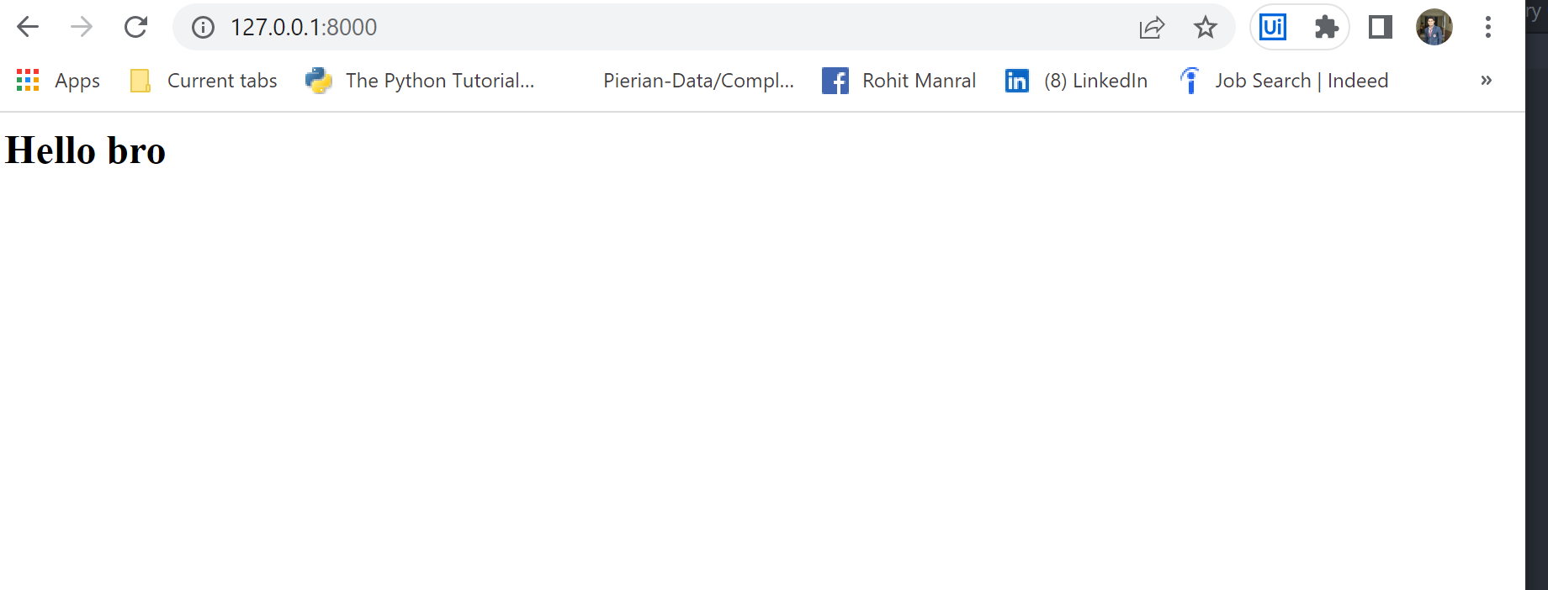

All the **.js** **files** in the end of **home.html** page are called static files, even the **image files** are **static files**.

To make all the **static files** work, we will go to our **project level directory** in **Atom(carzone)** & create a **static folder**.

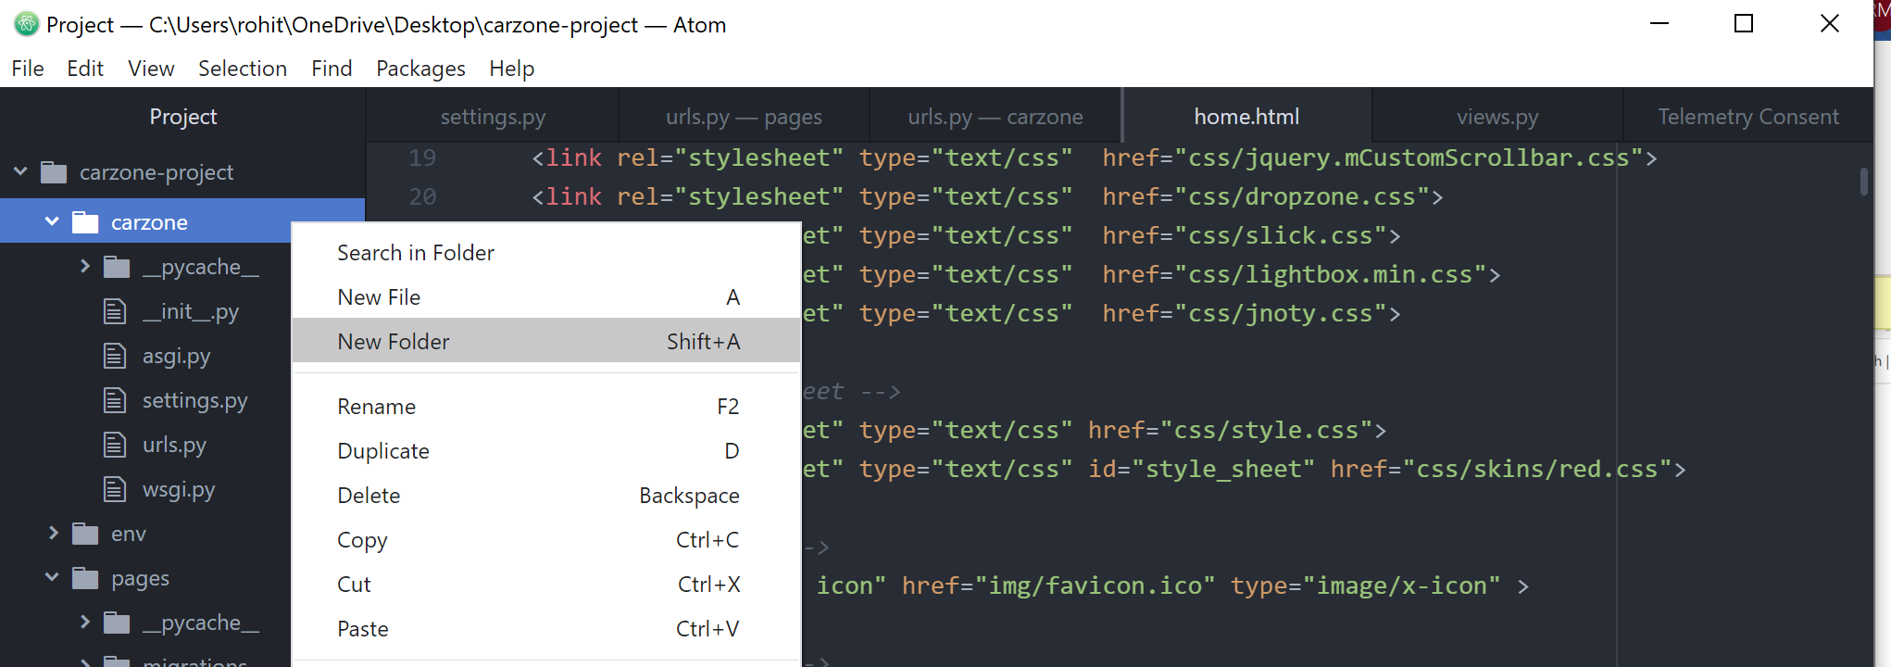

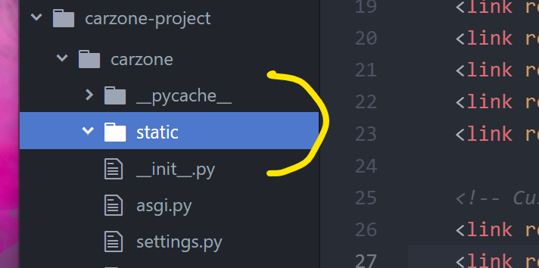

Now, go to html templates folder, as we need the css, img, font, and js folders, so copy them & paste these 4 folders inside the static folder.

Now, we need to register our all static files in carzone🡪static🡪settings.py file

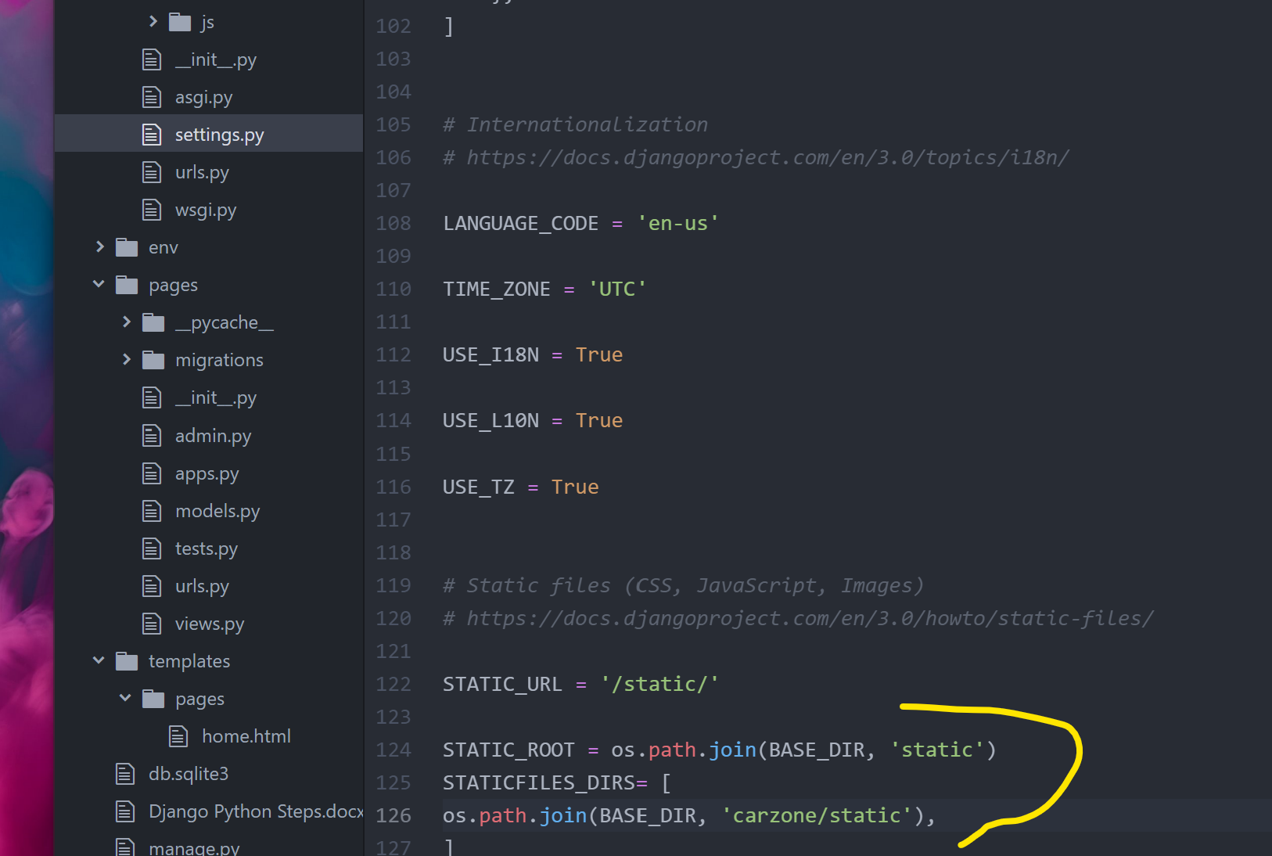

* Now, go to Git Bash & run:

python manage.py collectstatic # it will collect all the static files & folders we created and will create a new static folder with including admin static files as well. So, after running this command you will see the new static folder will be created in root directory.

python manage.py --help

* Now, go back to **home.html**, use out static files. We will do it by

**Starting of home.html file:**

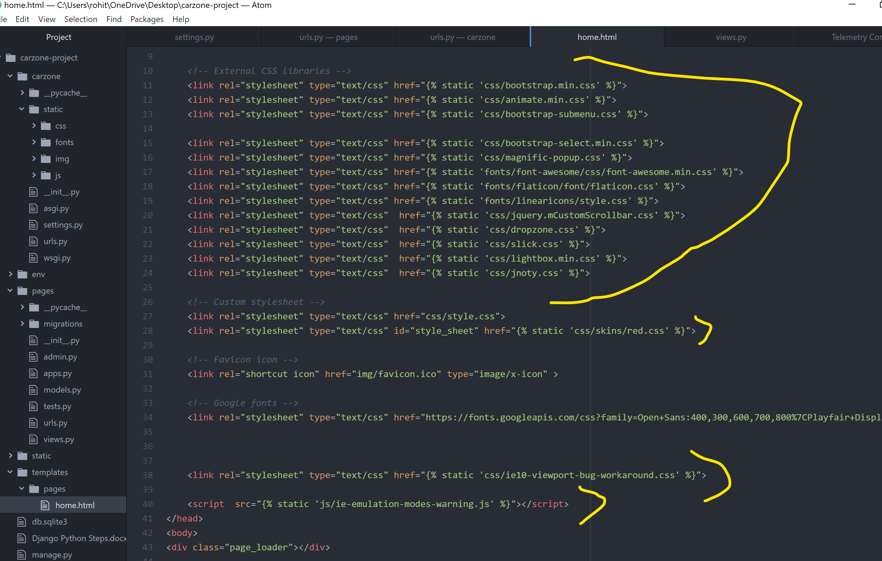

**Ending of home.html file:**

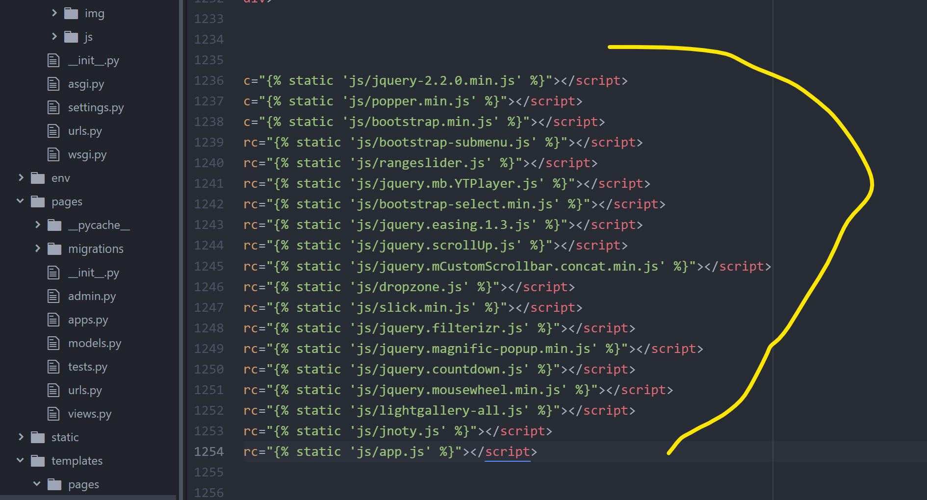

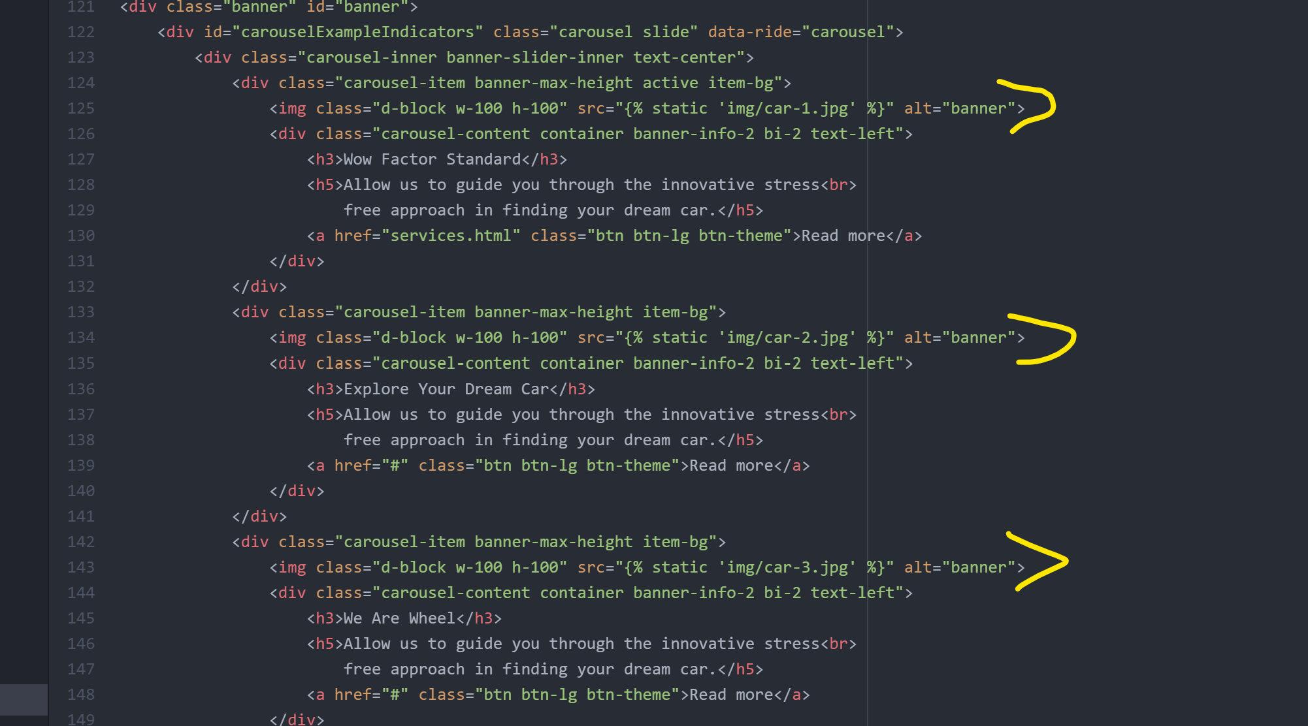

* Now, go to **carzone\static\js\app.js**

Press **ctrl+F**

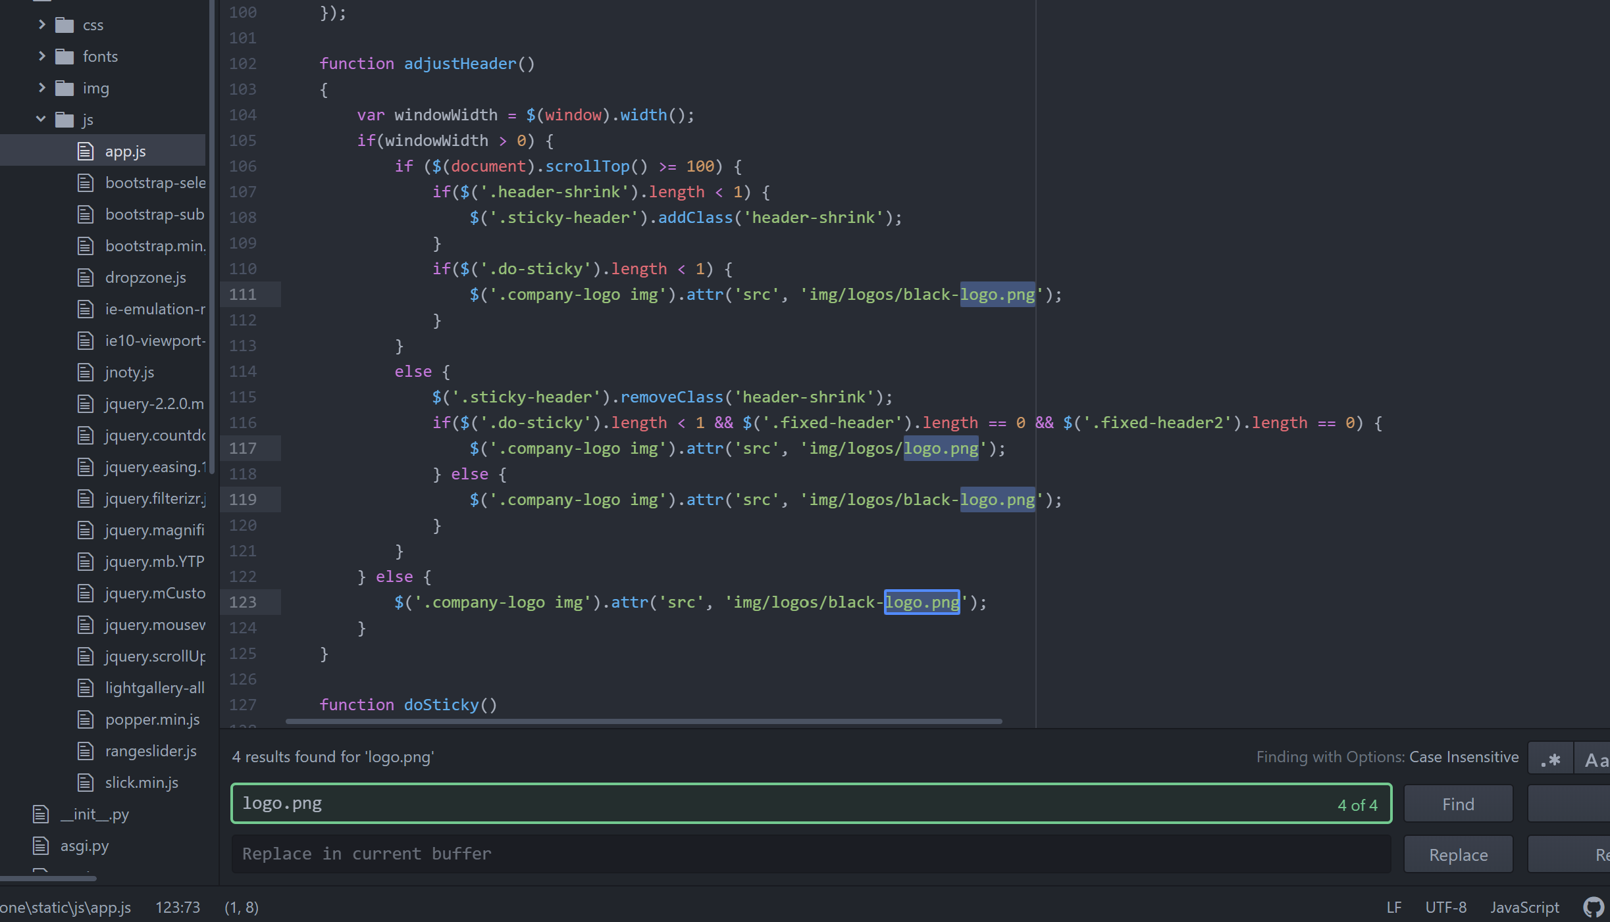

Include ‘static/’ before logo.png path at all 4 places.

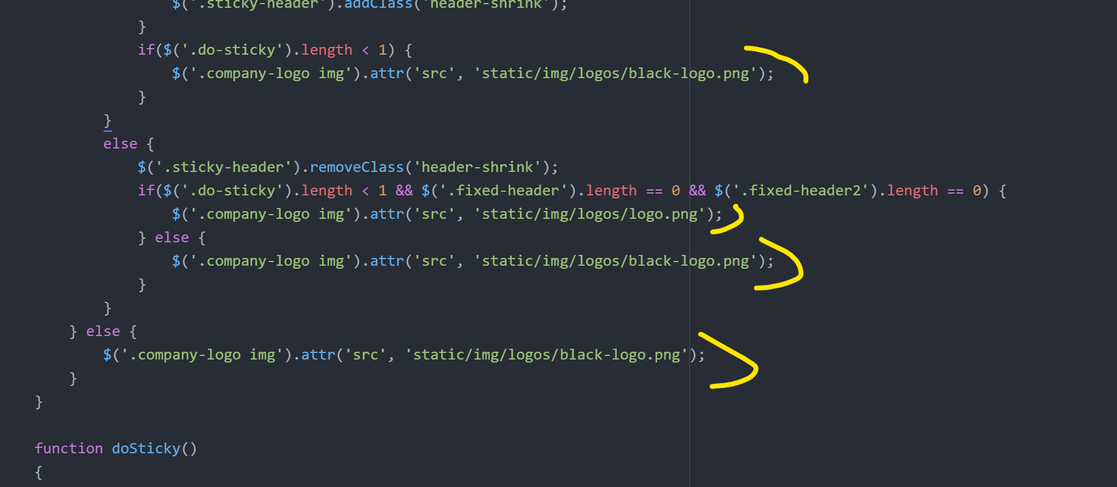

* **Creating the Base Template:**

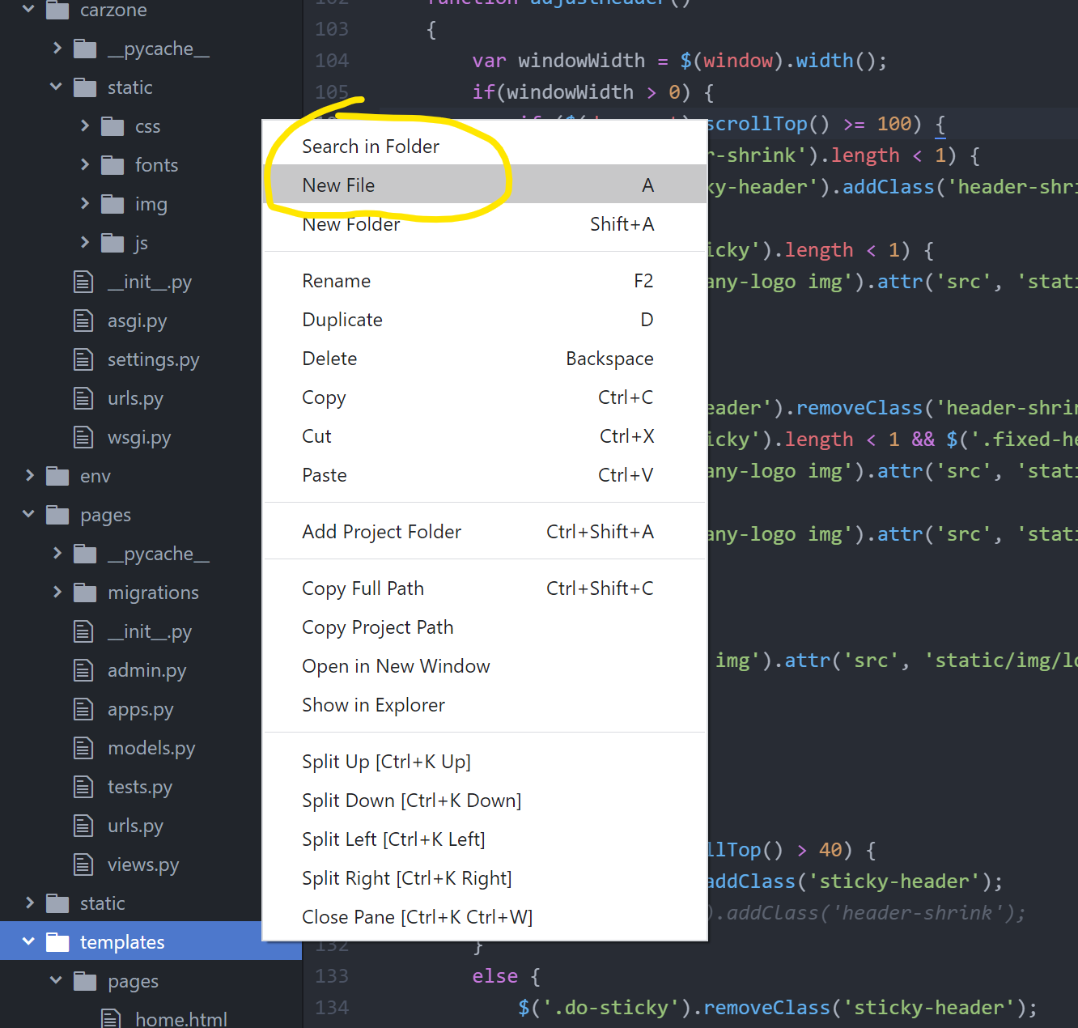

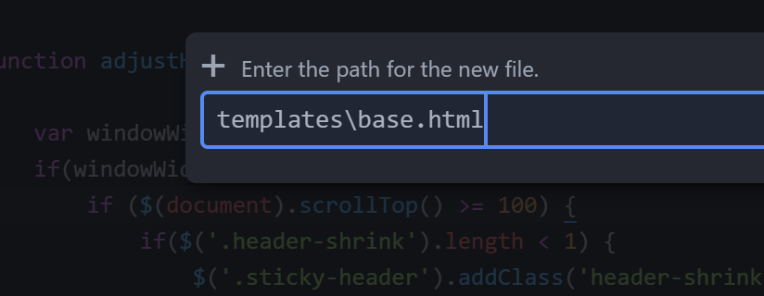

* Now go to **home.html** and **cut** code from **start** till **MAIN HEADER END** & **paste** that in the start of **base.html**

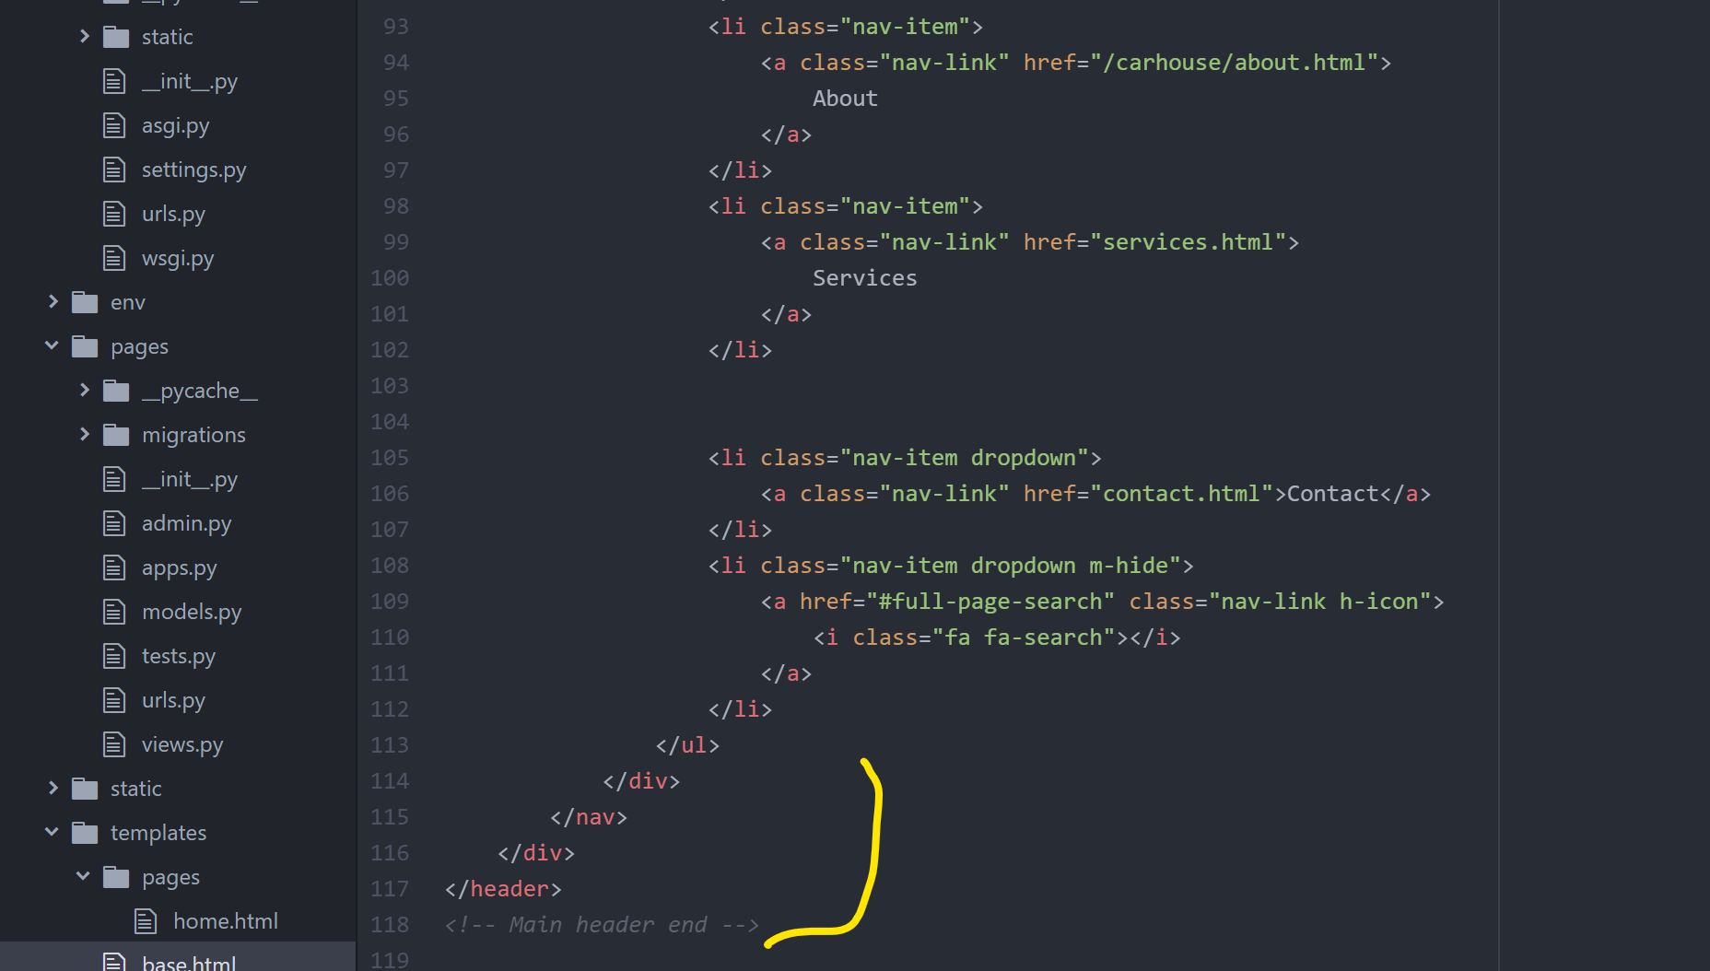

* Now, add this part under **Main Header end**

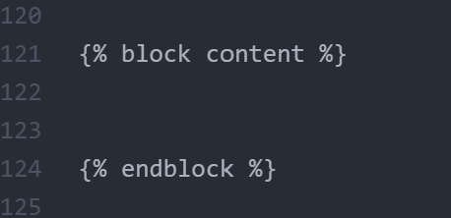

* Now, **cut** this last part from **home.html** & **paste** at the end of **base.html**

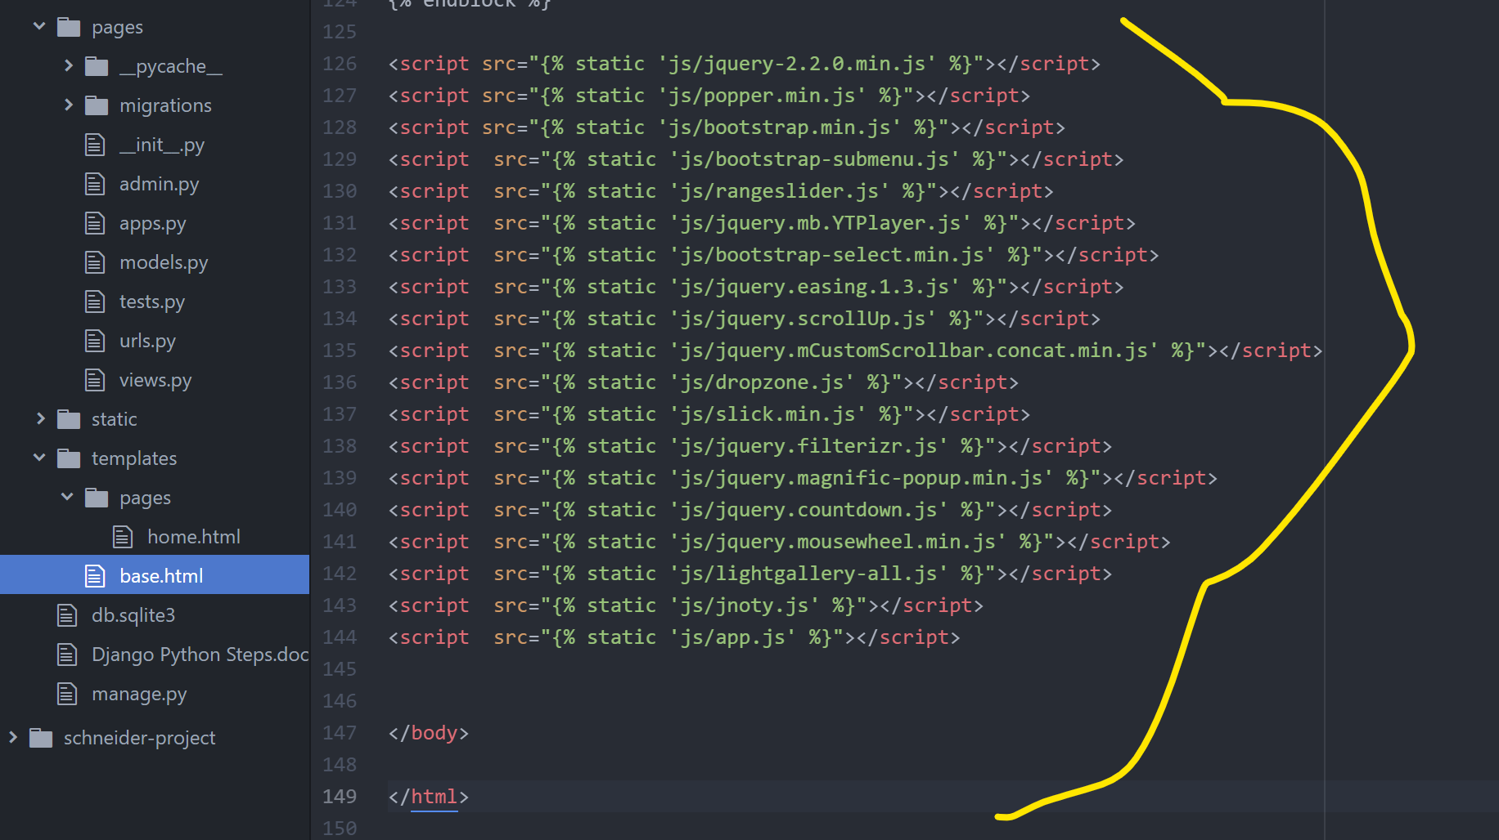

* Now, got to **home.html** and add some commands at the starting

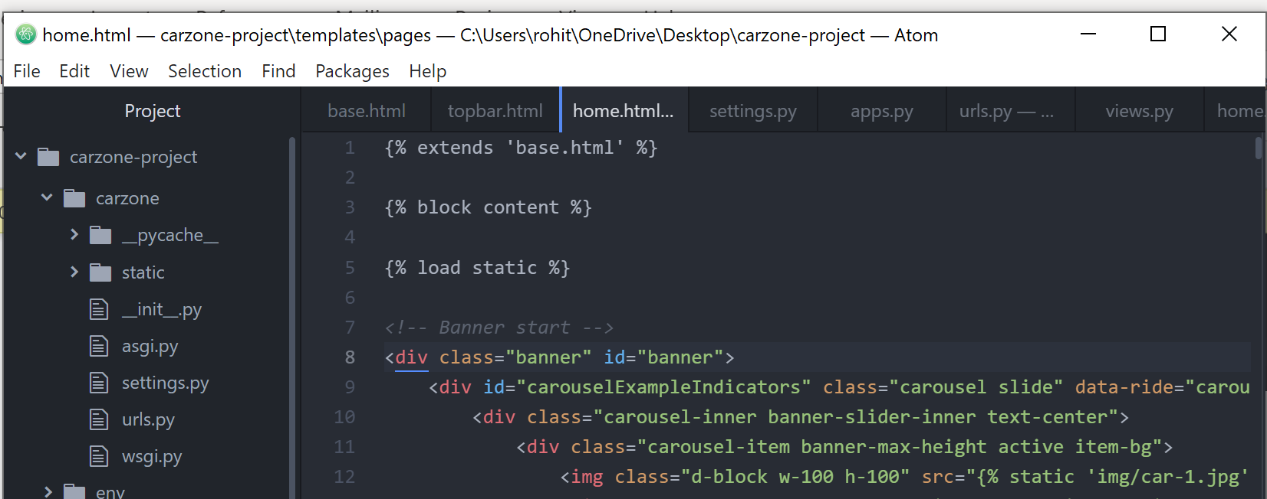

Add this at the end of **home.html**

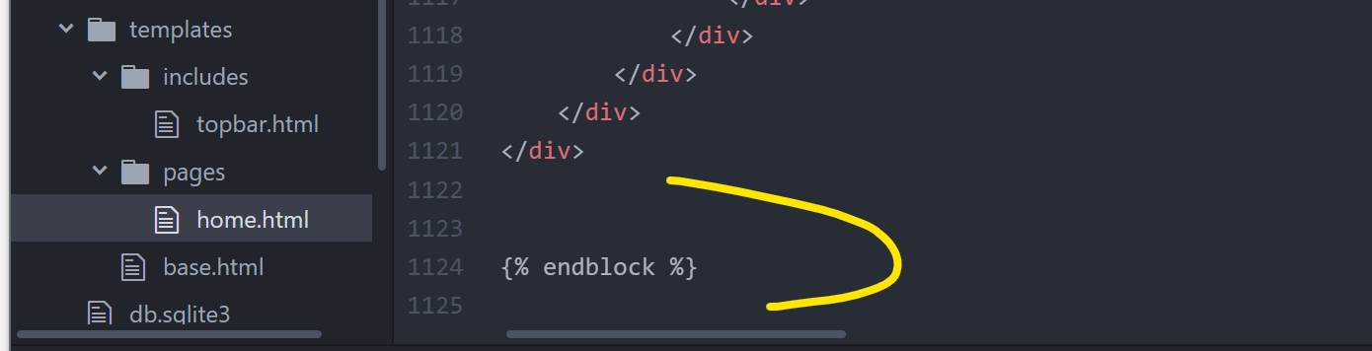

* Make some folders & files inside **templates** folder

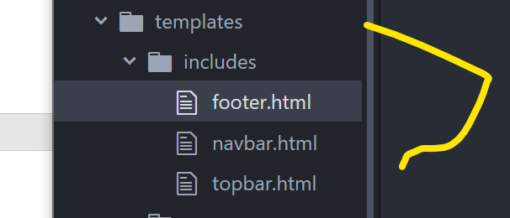

* Now, go to **base.html**, **cut** the **top-header** part & **paste** it in **topbar.html**.

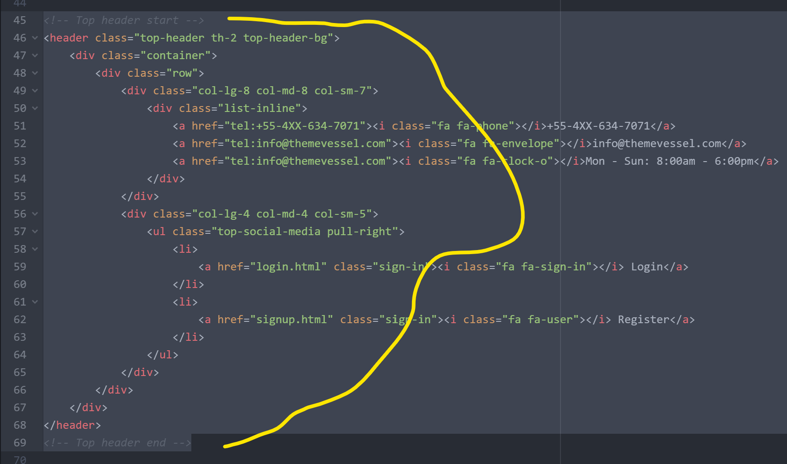

* Again go to **base.html**, **cut** **Main-Header** part & **paste** in **navbar.html**

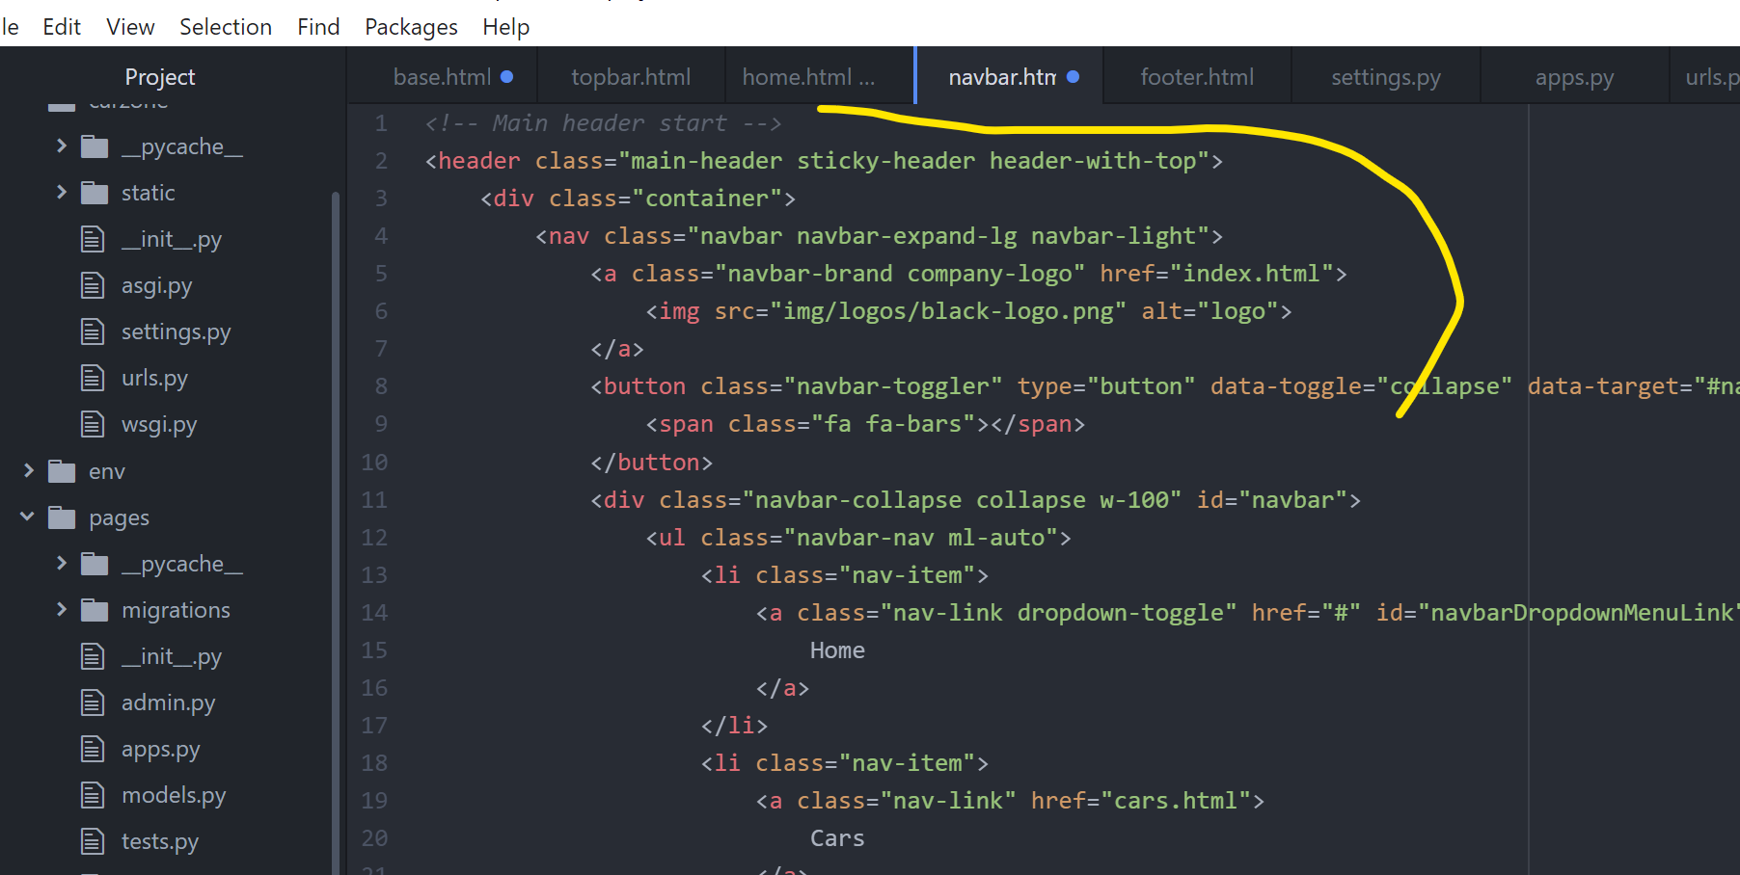

Also copy these changes in navbar.html

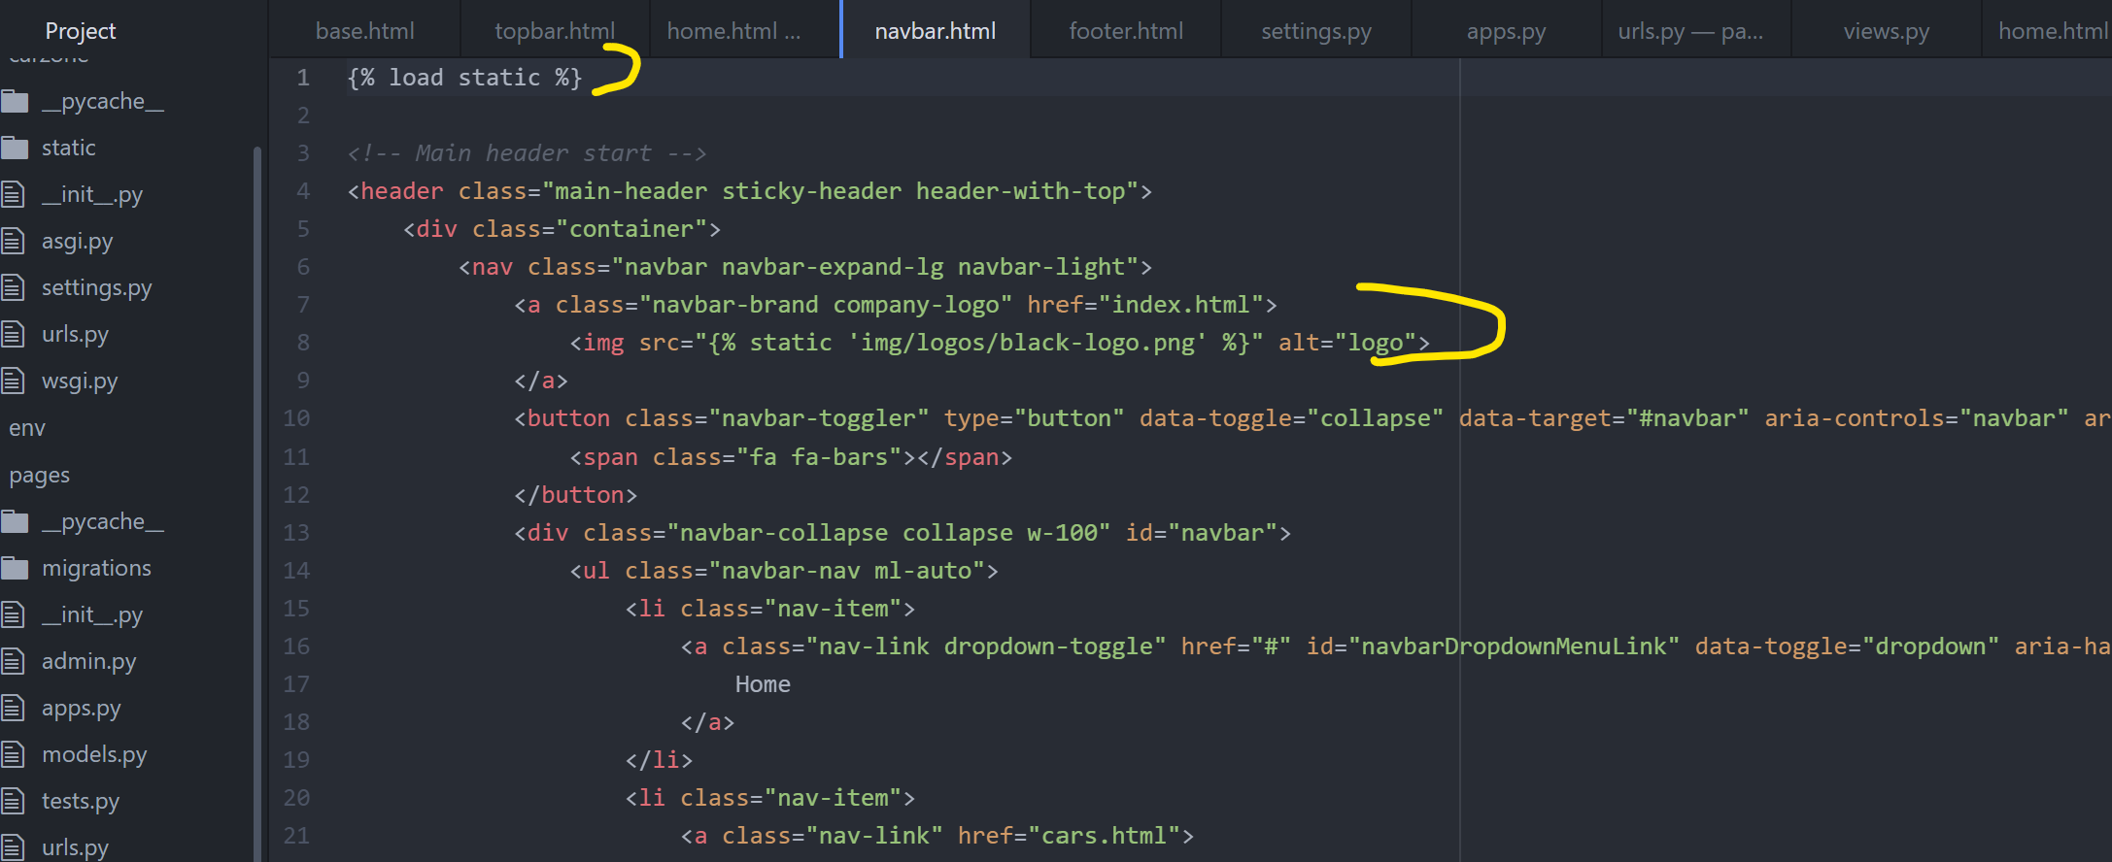

* Again go to **home.html**, **cut** **Footer start-end** and **paste** it in **footer.html**

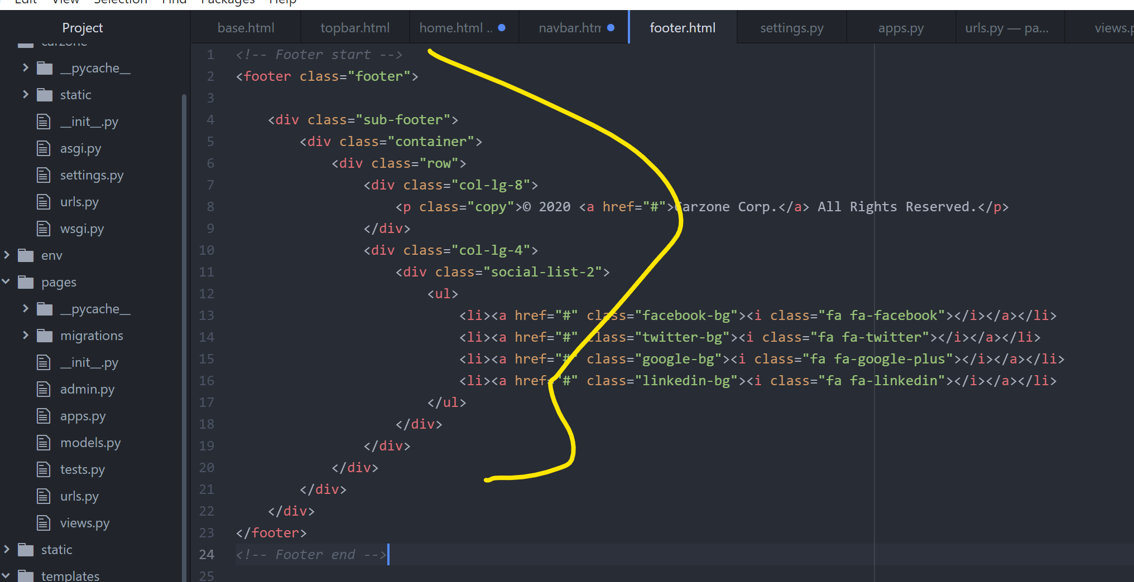

* Go to base.html and add these lines

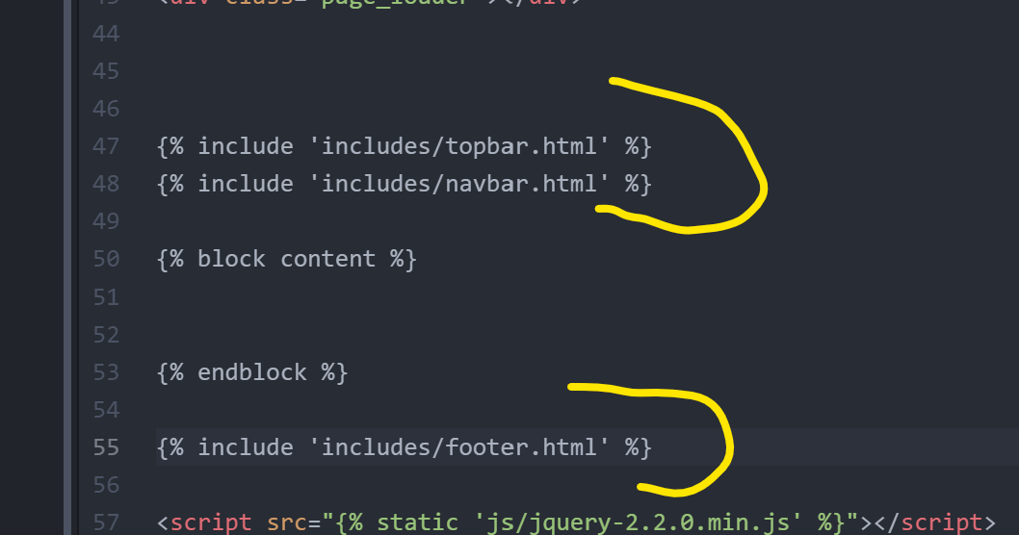

**Making the Navigation Dynamic link for About page**

* Go to pages🡪urls.py & add these commands

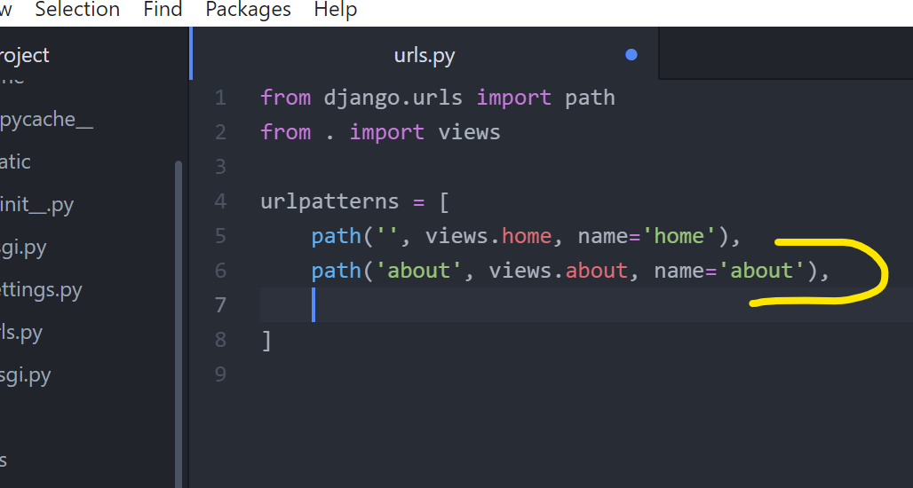

* Now, go to pages🡪views.py & add these commands

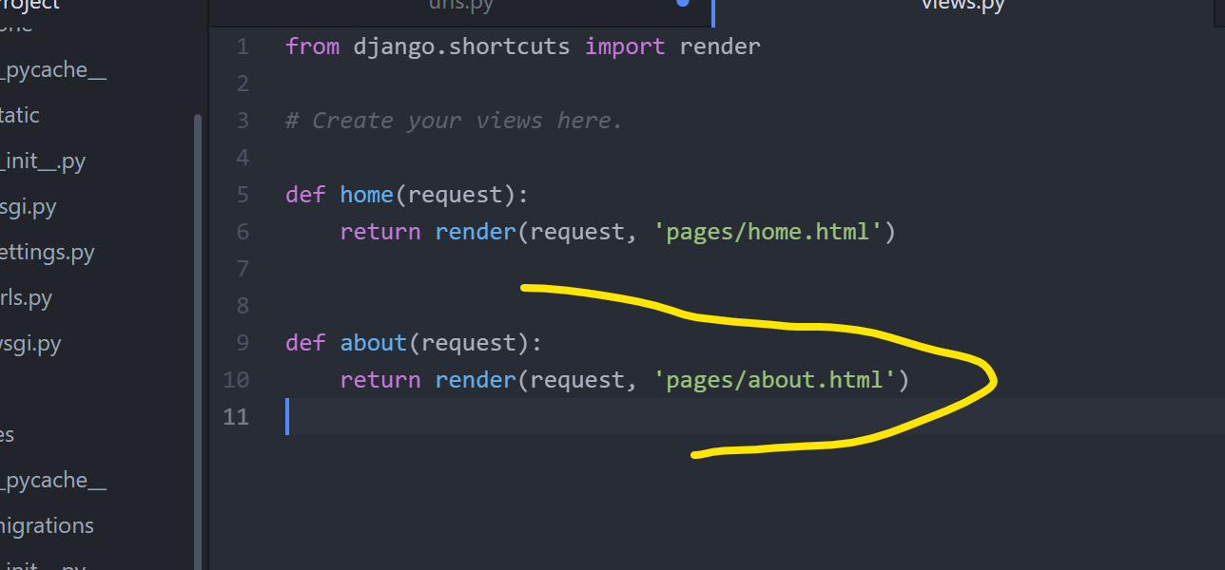

* Make these html files in **templates🡪pages🡪** folder

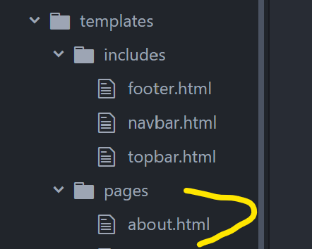

Write some random text in about.html. Then, try <http://127.0.0.1:8000/about> in browser

* Go to navbar.html and fix this link reference

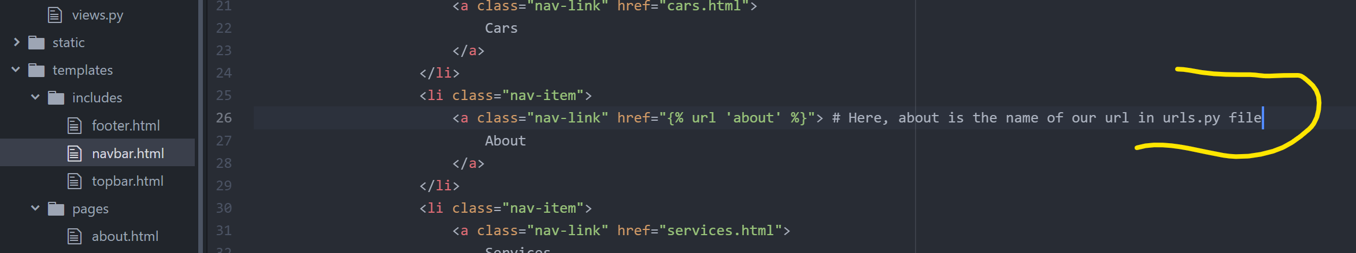

* Repeat the steps in above table for **Services** & **Contact** links

**For the Cars Navigation Link we will make a separate** Cars app **to show all the cars and their operations there.**

**Same thing for Login & Register links where we will make an Accounts app and inside that we will make a login & a register page.**

**For the Pages app, we made Home, About, Services, & Contact pages.**

* Now implementing our Bootstrap template inside **About (about.html), Services (services.html), & Contact contact.html) pages**.

**For about.html Page**

* Go to carhouse html data files & copy contents from **Sub-banner-start** to **Our-team-end** and paste in **about.html**. Also add some commands as below

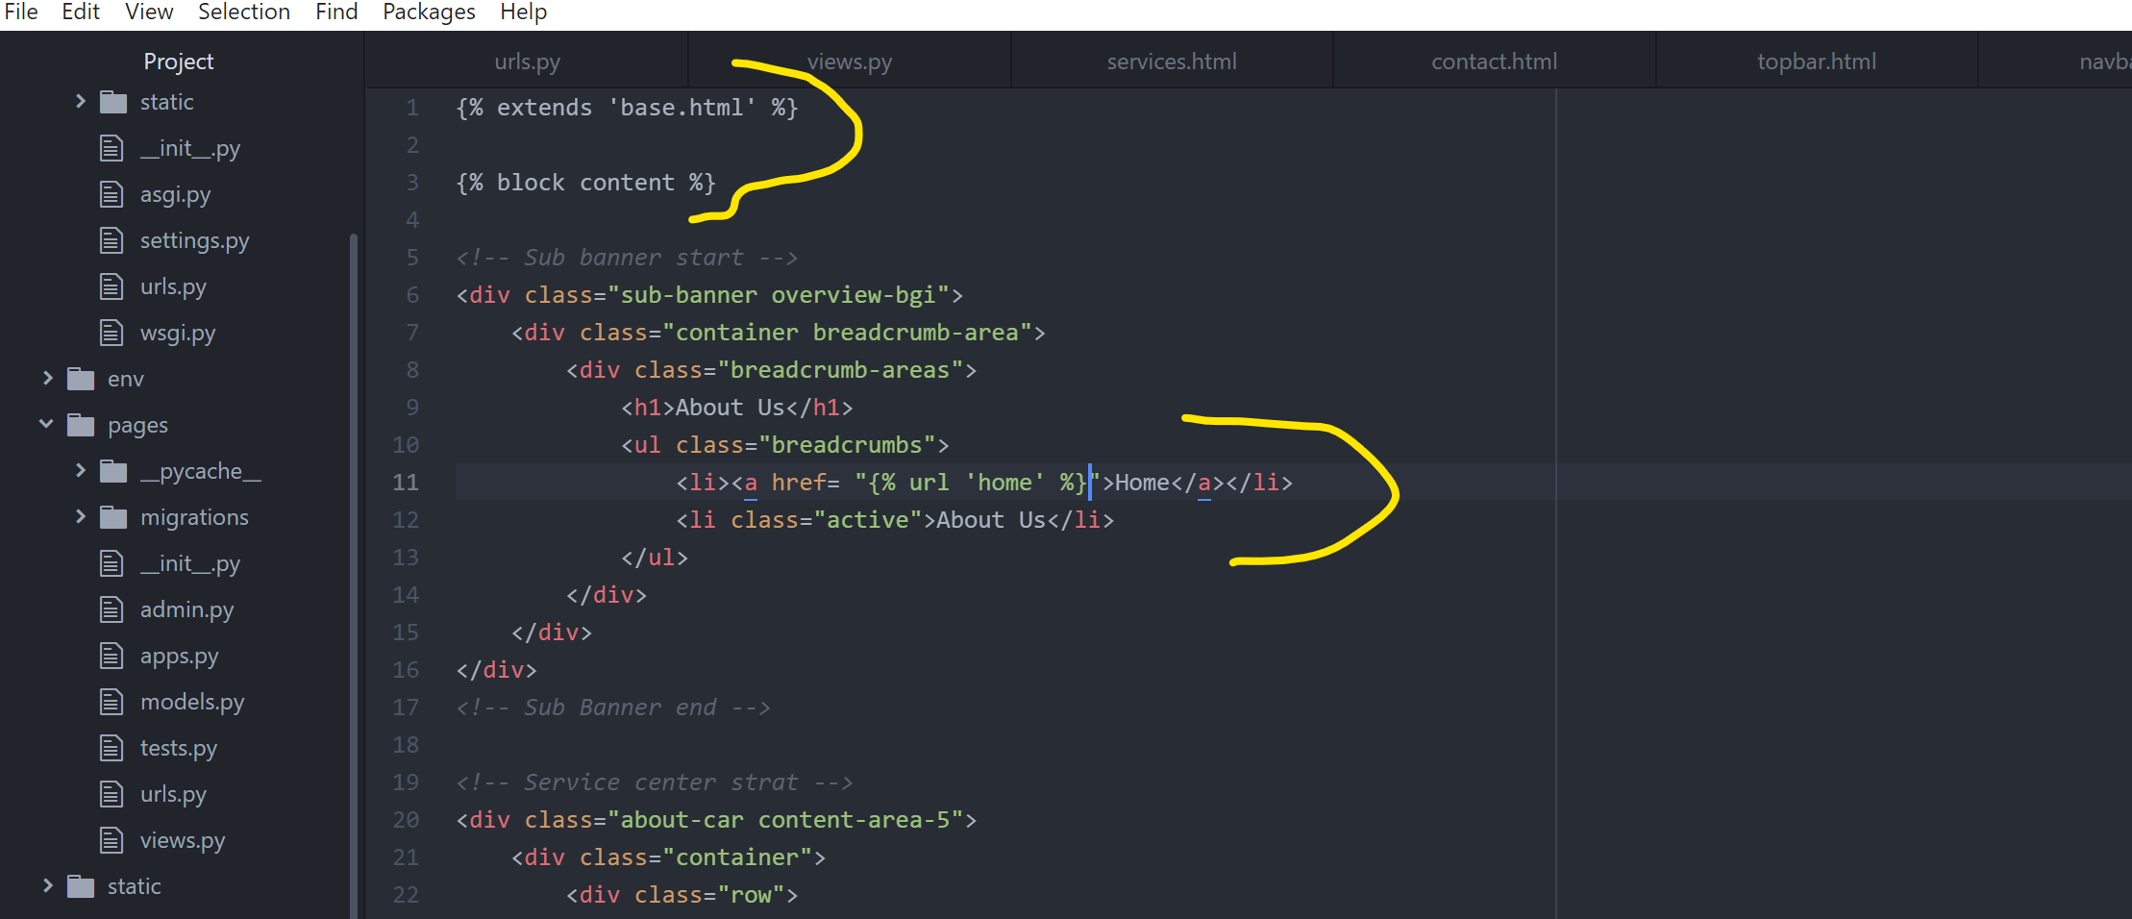

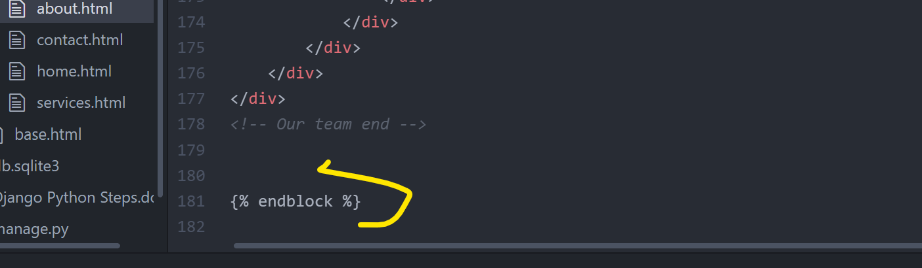

* Still fixing some images & text in **about.html**

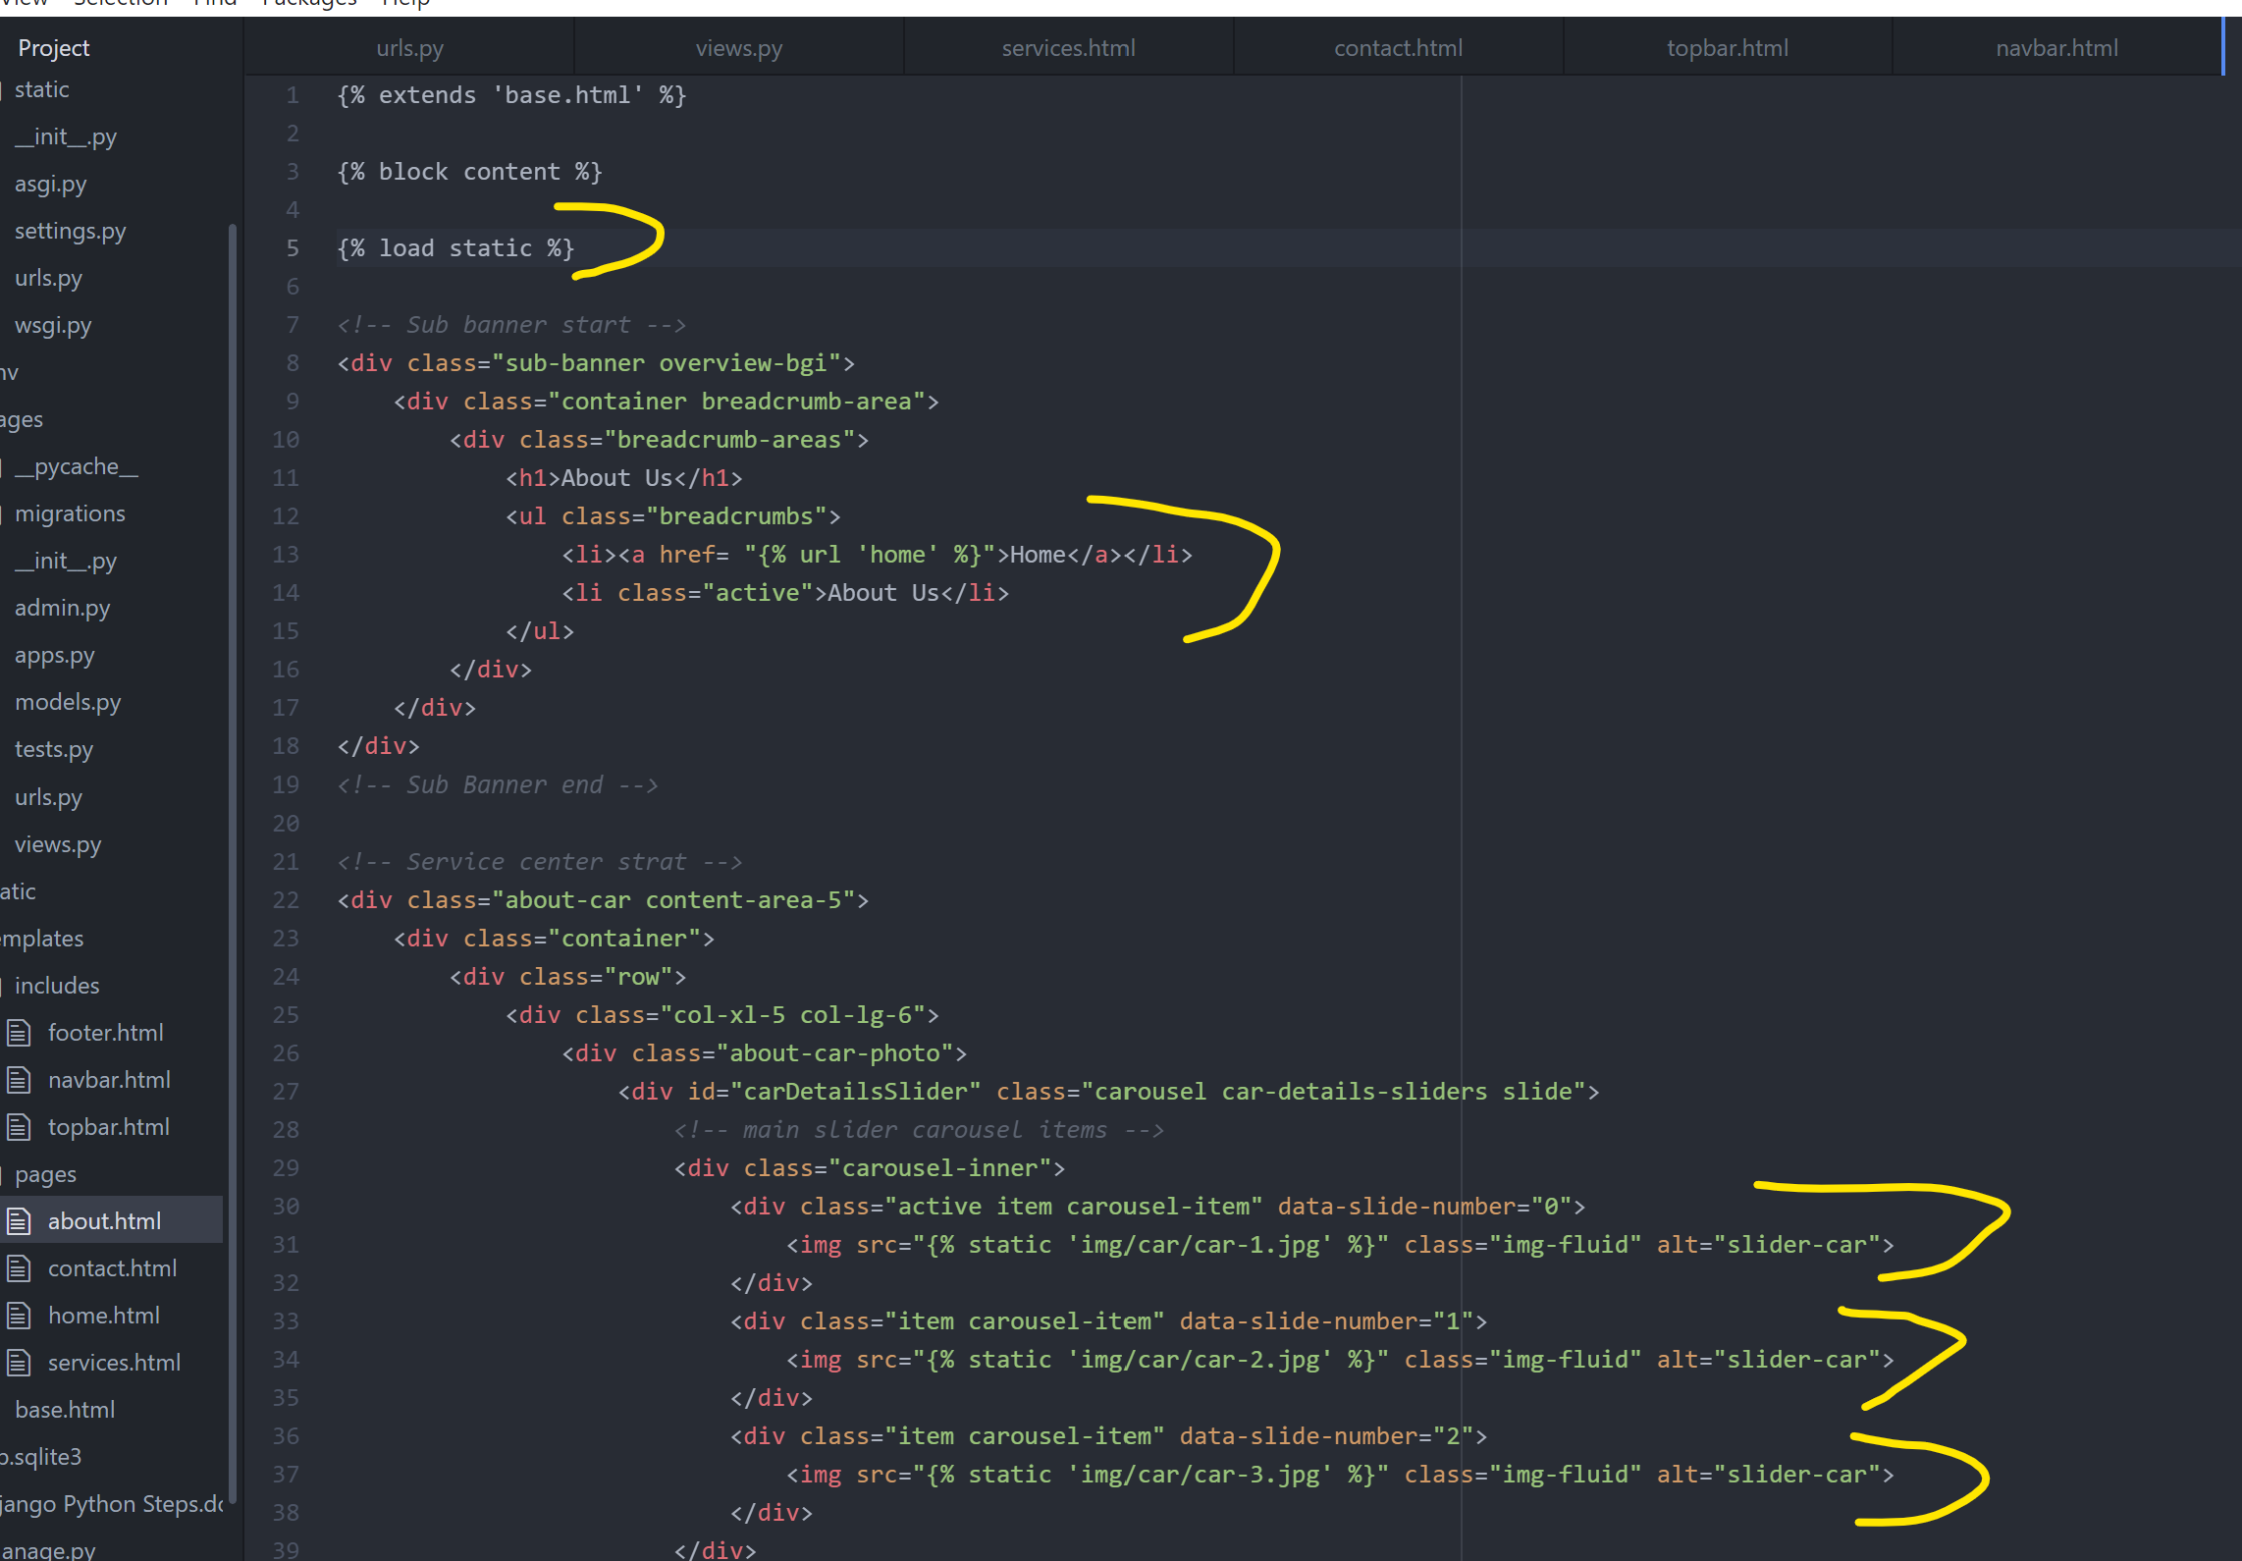

* Now fixing thumbnails

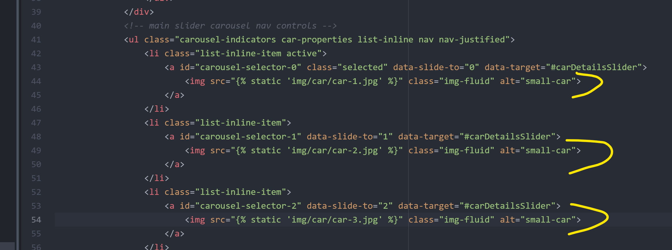

**For services.html Page**

Same as above

**Sub banner start- services end**

**For contact.html Page**

Same as above

**Sub banner start- contact 2 end**

**Search icon** not working inside **About, Services, & Contact pages**

* Go to home.html at bottom of page and look for **Full Page Search** , cut that code part & paste at the below position of base.html.

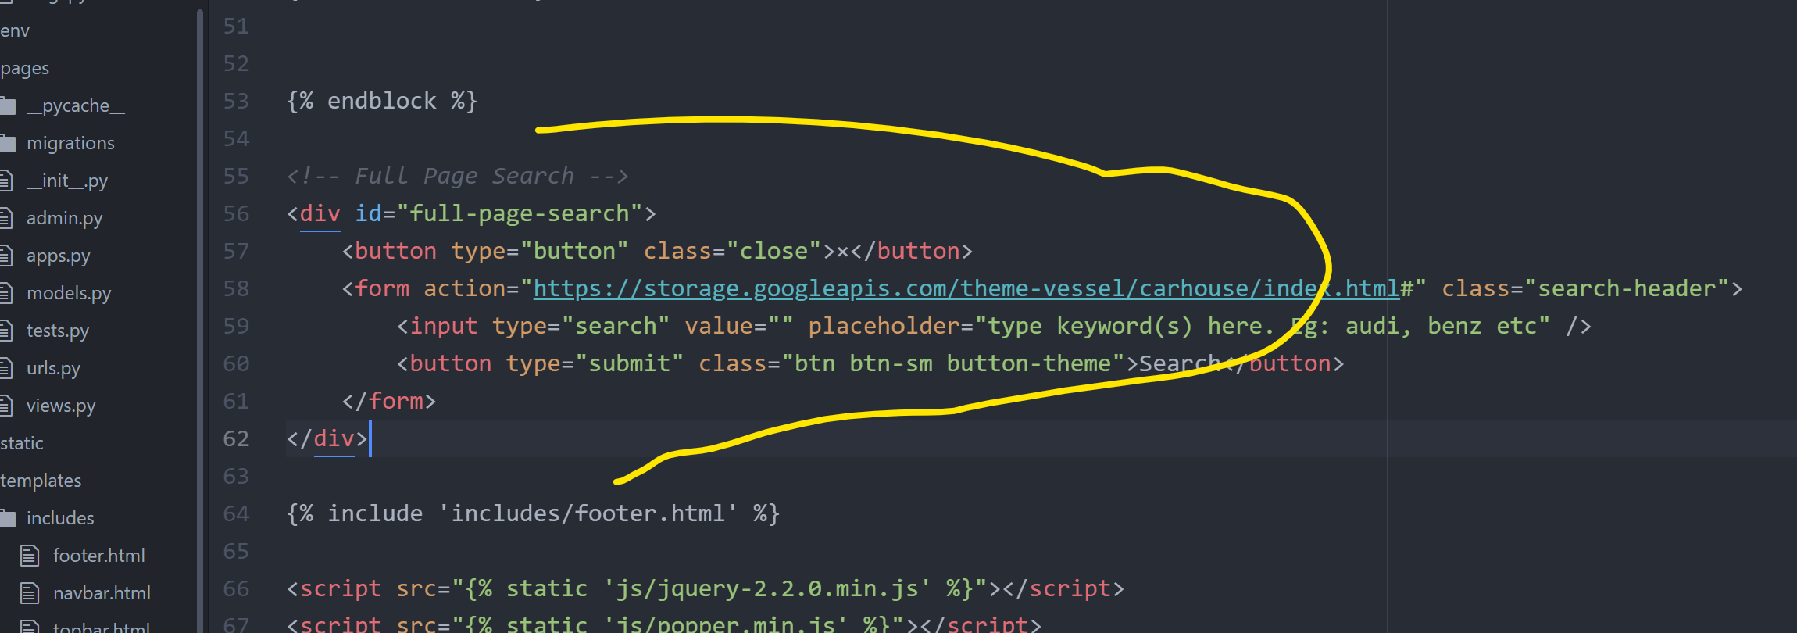

* Go to navbar.html & fix it

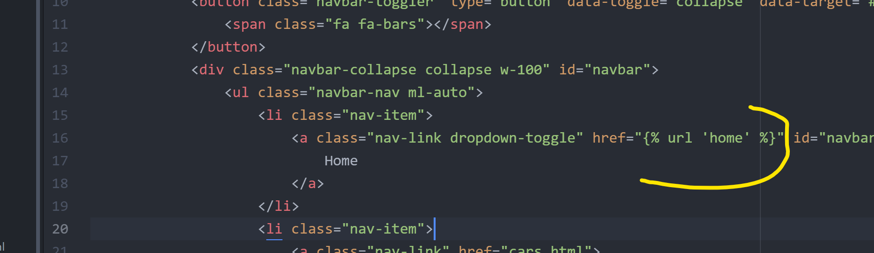

**Install PostGreSQL**

Create a database in PostGre

* Register out database in carzone🡪Settings.py file

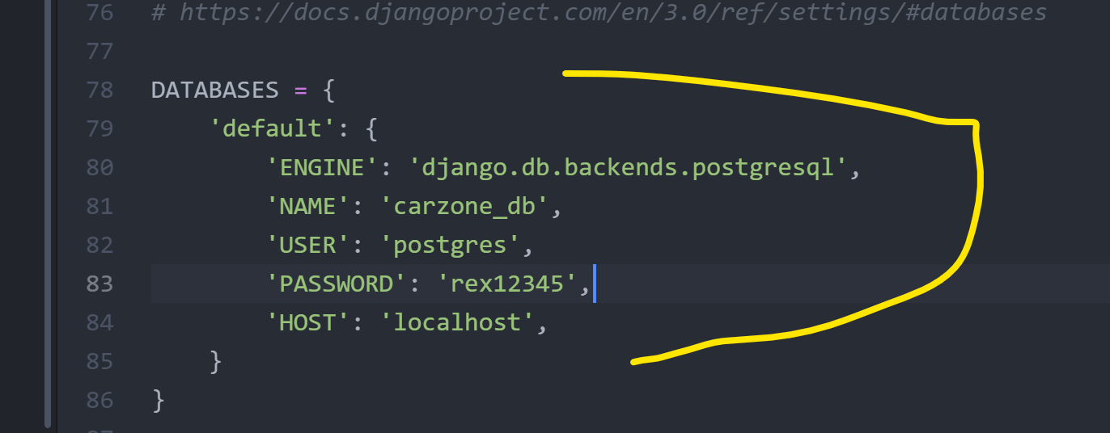

**Creating superuser for Django Admin**

* Go to Gitbash window

python manage.py makemigrations

python manage.py migrate

winpty python manage.py createsuperuser

python manage.py runserver

On Web Browser: http://127.0.0.1:8000/admin

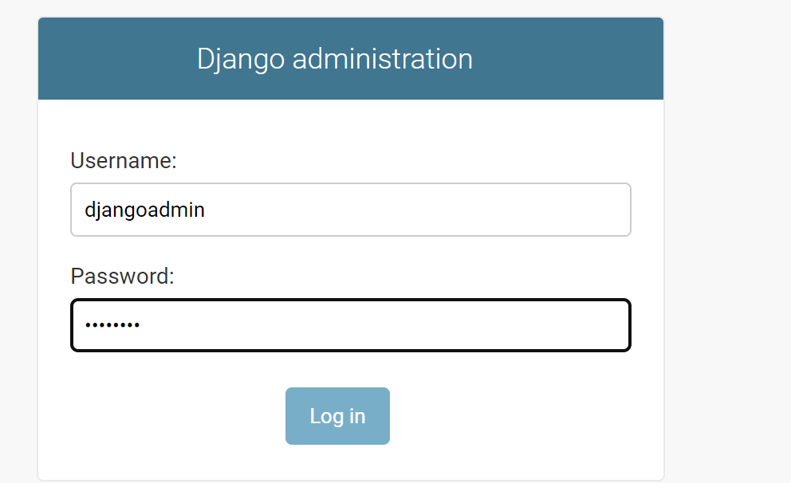

* Fill following details

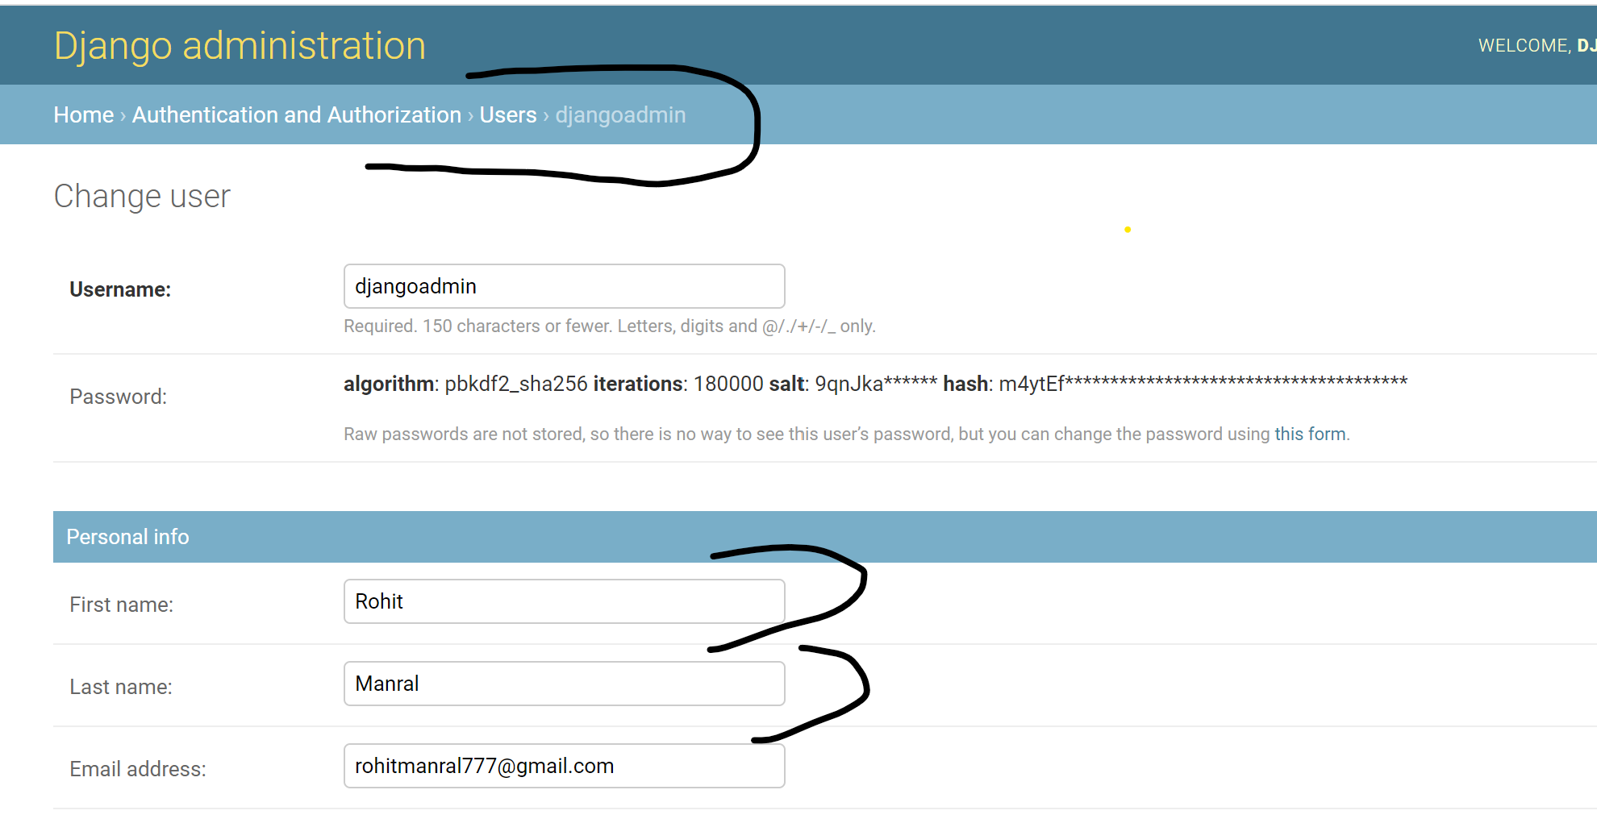

**Creating Model for Teams app**

Now, we will create the Team Model to display the information of all the Team members on the home page.

* Go to pages🡪models.py

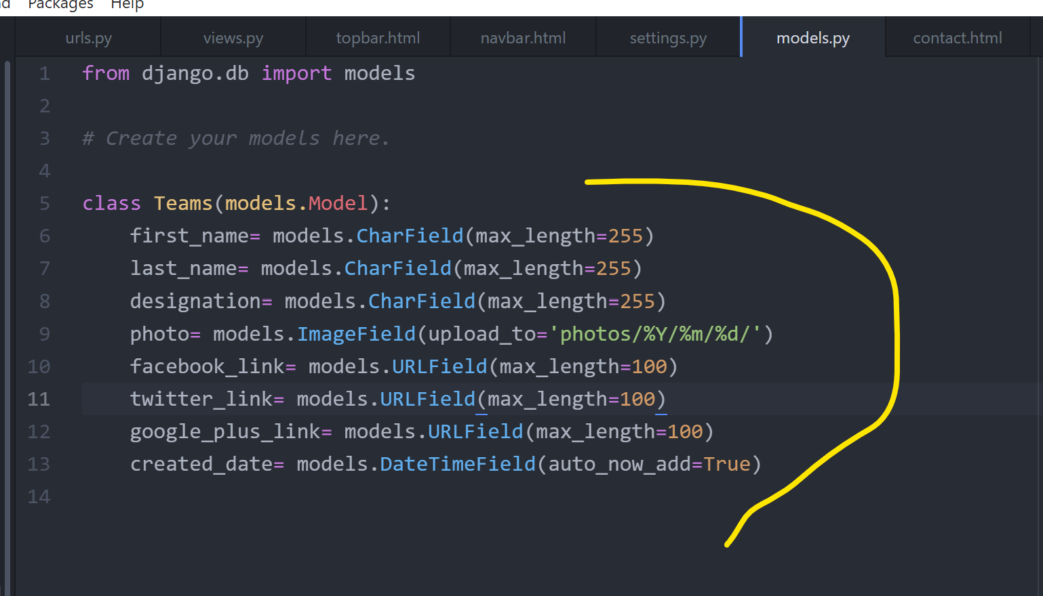

pip install pillow

python manage.py makemigrations

python manage.py migrate

python manage.py runserver

* Our Teams model is not showing up in admin website because we didn’t register that in **admin.py** file as you can see below.

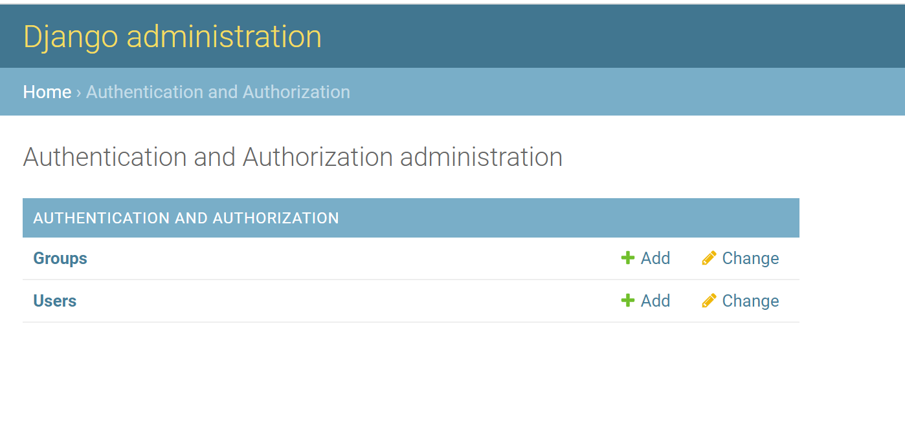

So, register that in **admin.py** file

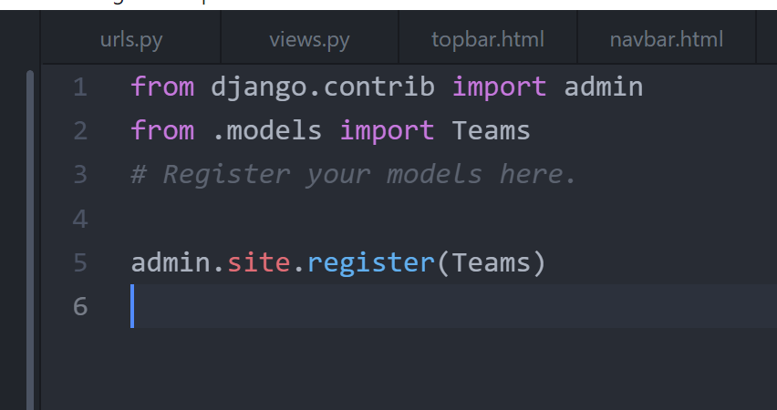

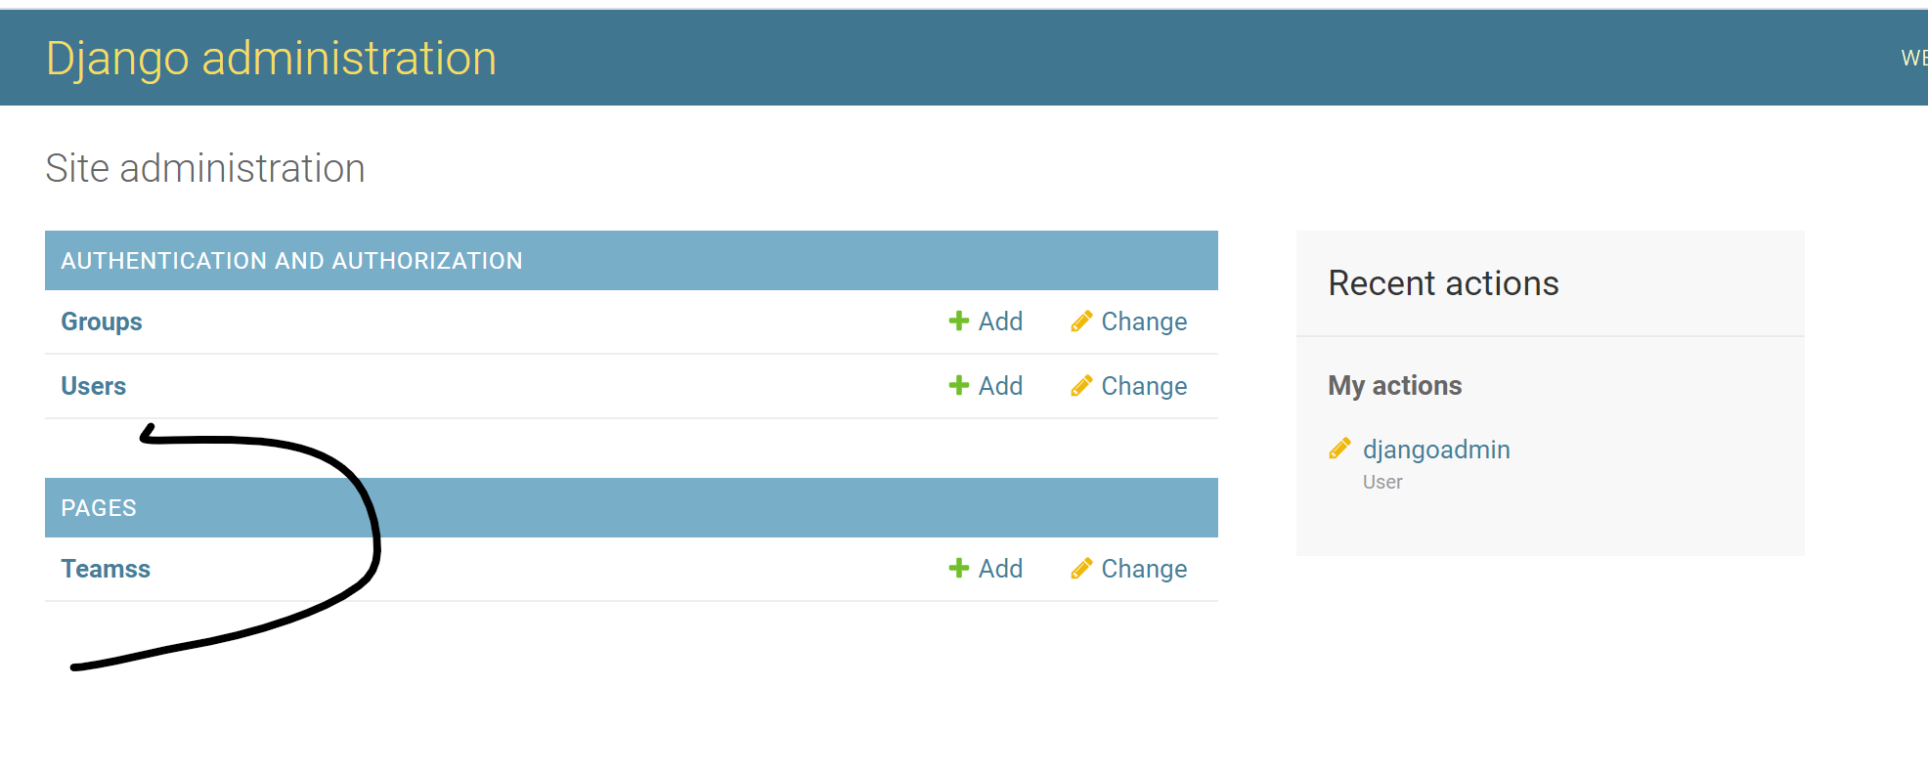

We can see the Teams model now but it got ‘ss’. To fix it change the model name to “Team” instead of “Teams”.

Whenever we change something in **model.py** file we have to run migration commands

python manage.py makemigrations

python manage.py migrate

python manage.py runserver

* Now add some items in Team model on admin website
* Then, add self function in **models.py**

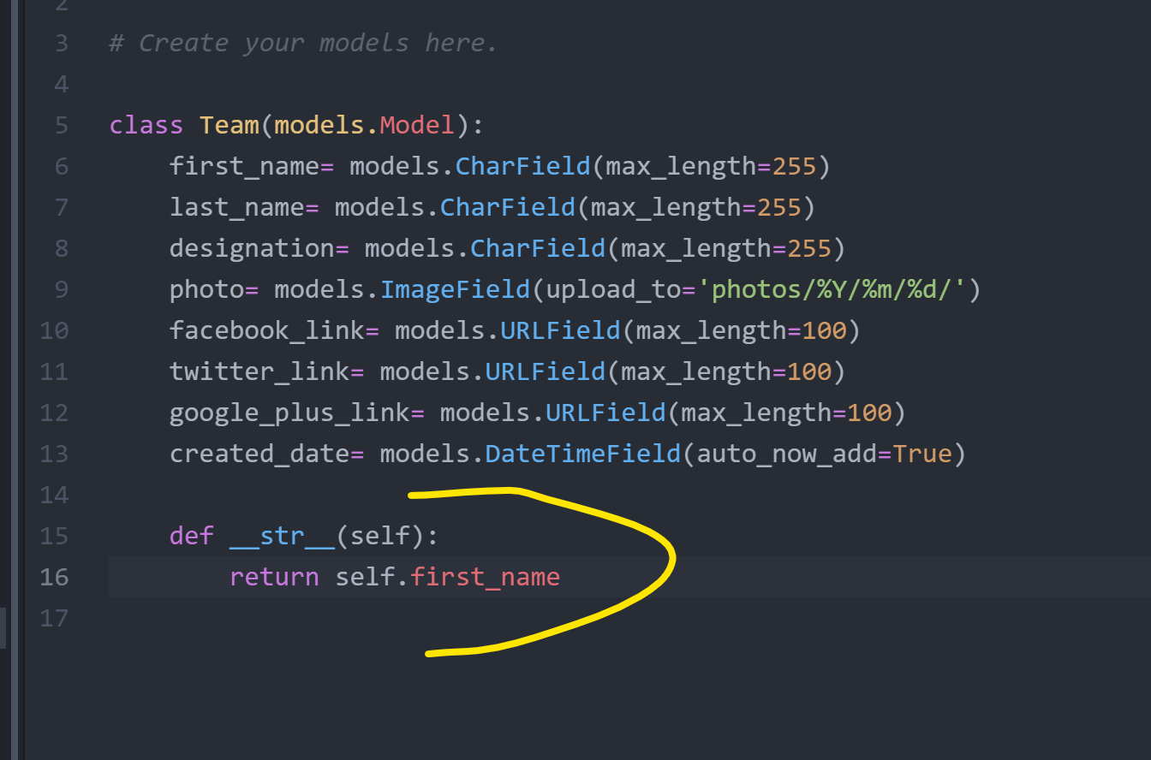

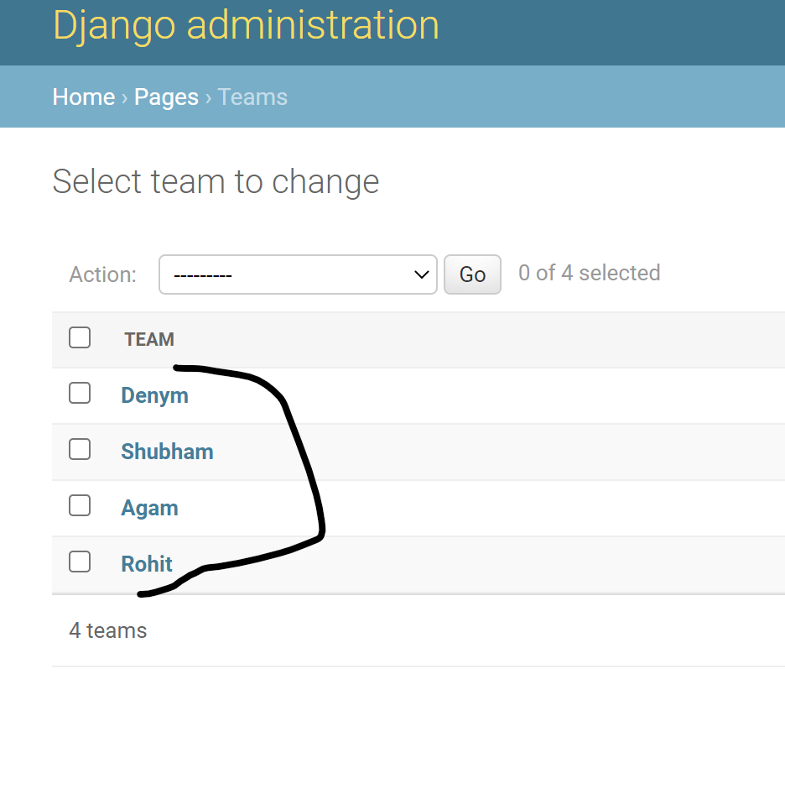

Now, you can see the **first_name** of all the team members

* Whenever we change something in **model.py** file we have to run migration commands

python manage.py makemigrations

python manage.py migrate

python manage.py runserver

**Media Files Configuration**

* Go to **Setting.py**

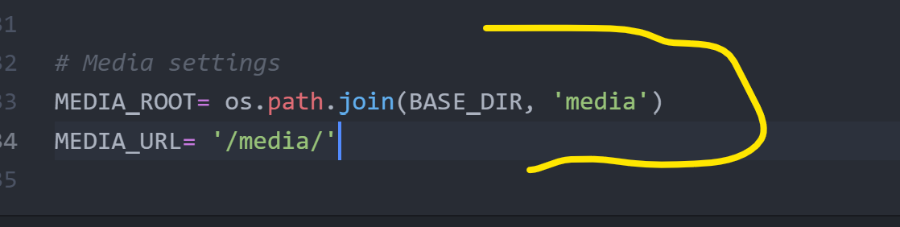

* Go to carzone🡪urls.py

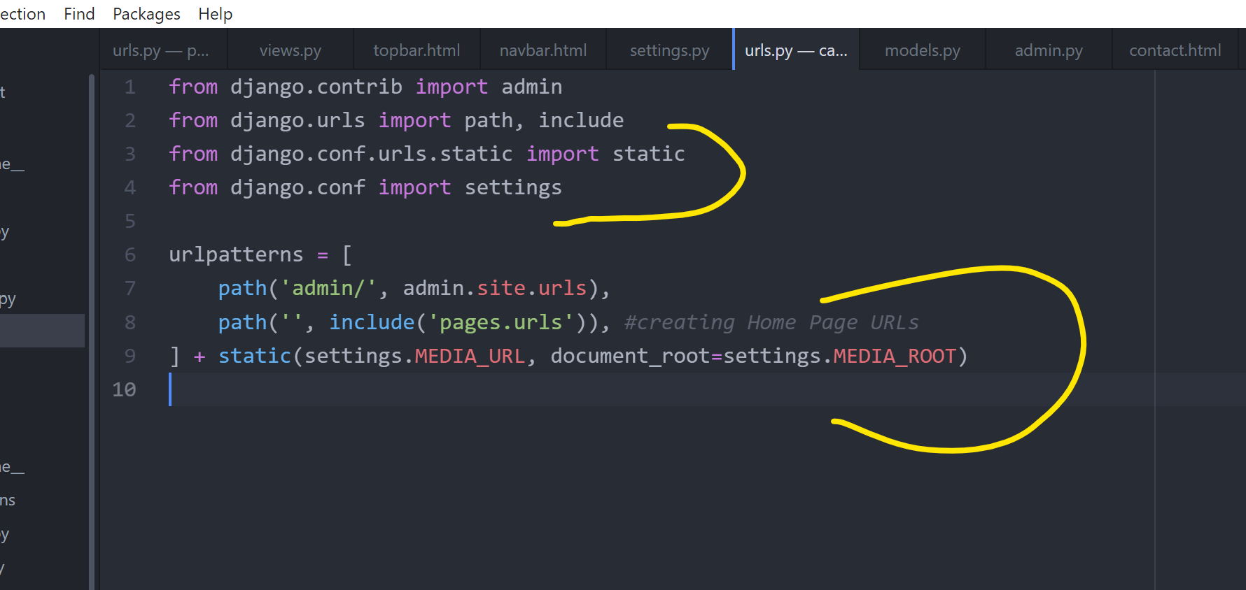

* Now again add photos of all the team members

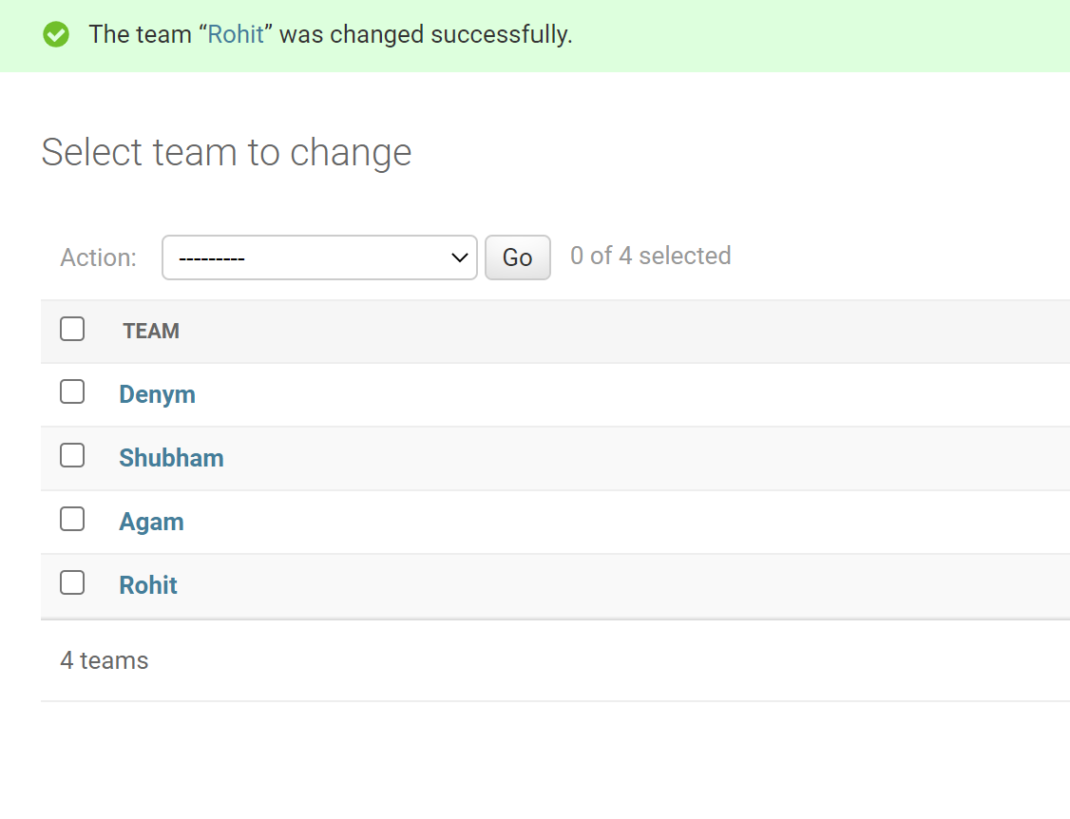

* Now adding the **Team members** data to **Front** and **About pages**

Go to **Pages🡪views.py**

As we need to fetch the Team Members data into out **Home and About pages**, so we will make some statements in **home** & **about functions** in **views.py**

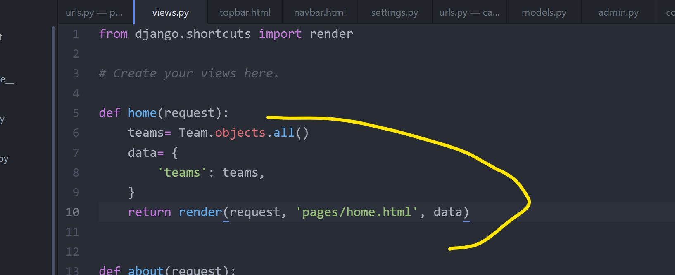

**from .models import Team** <-------- Also add this in views.py

Go to home.html [As we will show the fetched Teams model data here]

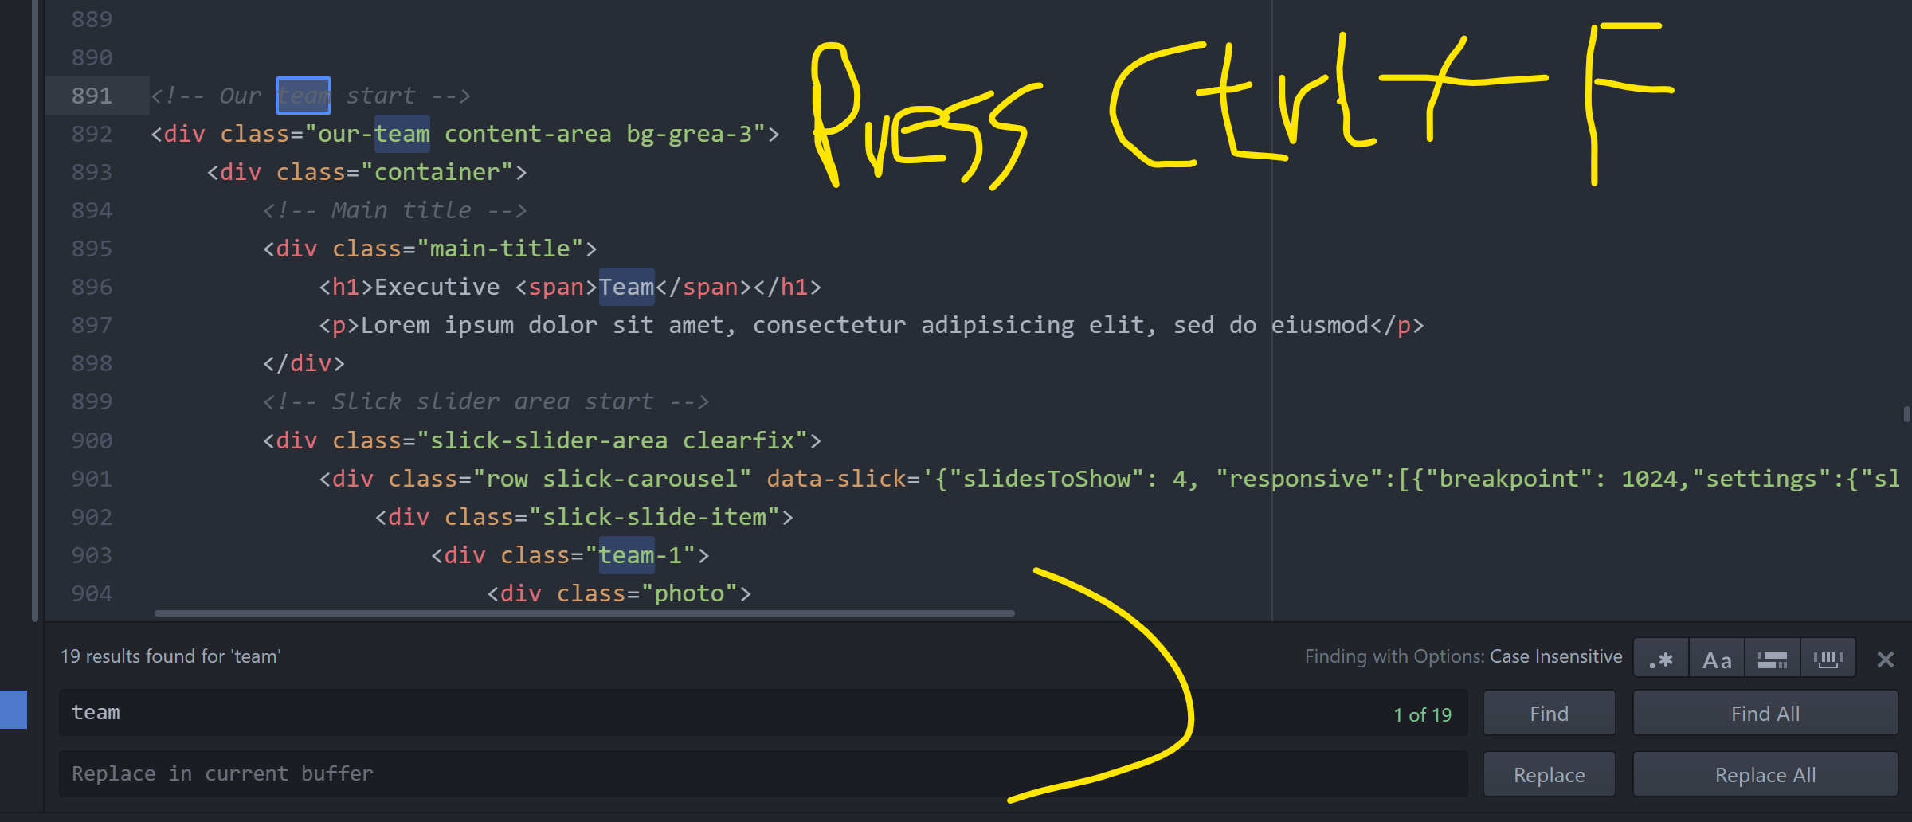

As we got multiple <div> in home.html for Team members data, so we will delete all and just keep one.

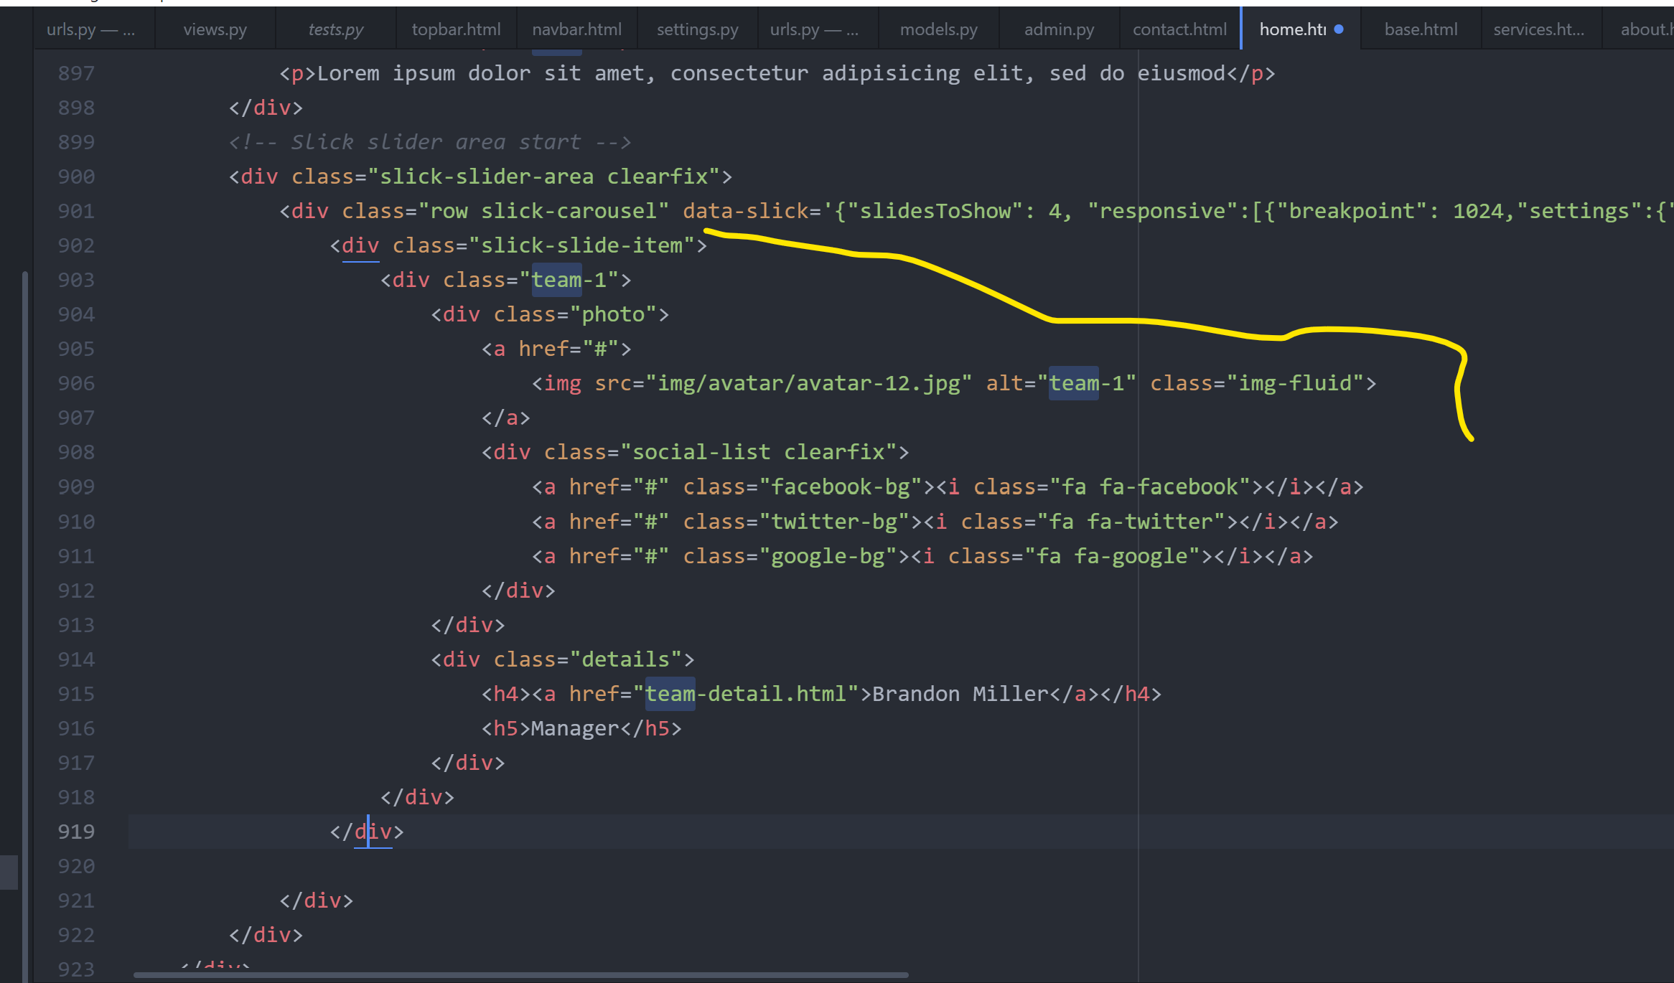

Make a loop to show all the Team Members

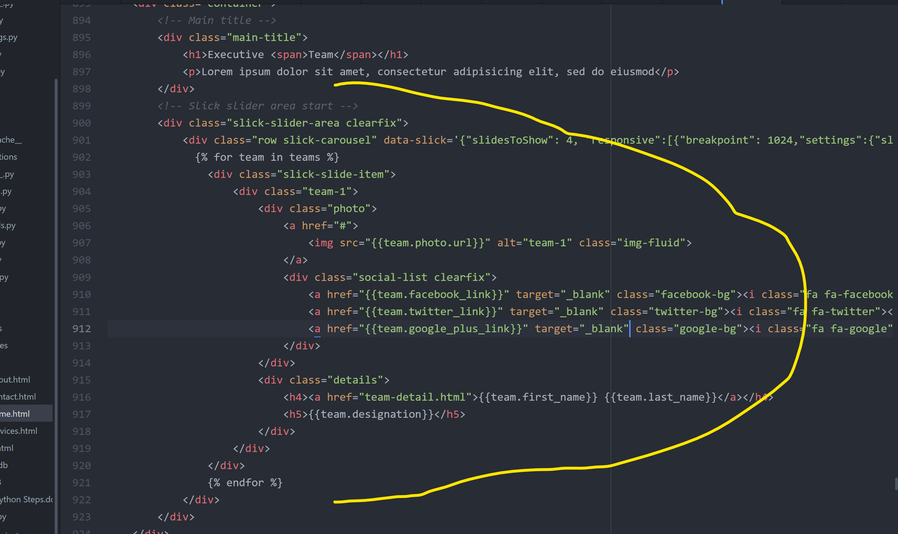

* Now, **copy** the same code as above in **about.html** to show **Team members**

Go to **Pages**🡪**views.py**

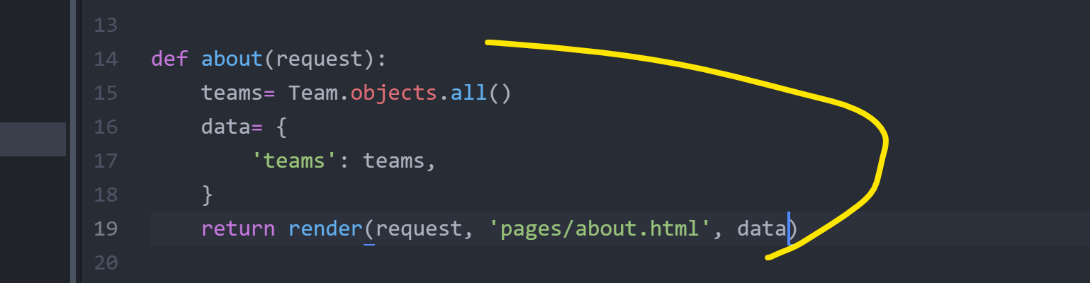

Go to **about.html**



* Go to navbar.html and fix this

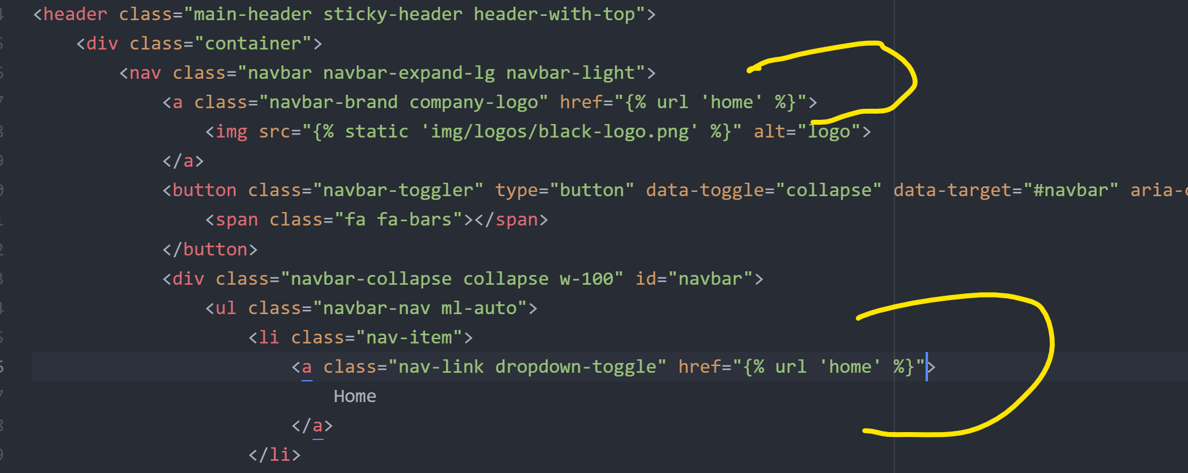

**Making a Table to see the data of Team Members in admin websites**

Go to pages🡪admin.py

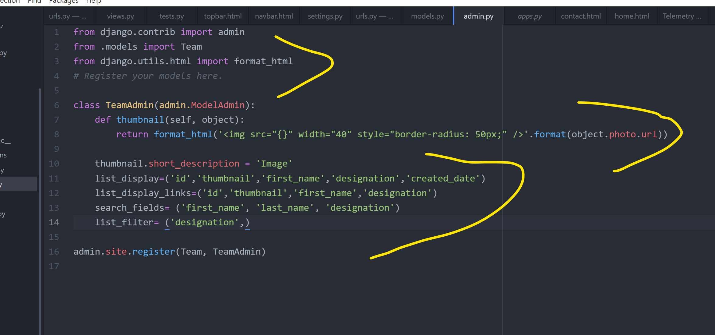

**Dynamic Navbar, Cars App, Car Model, & Migrate**

* Make some changes in header.html
* Make some changes in footer.html

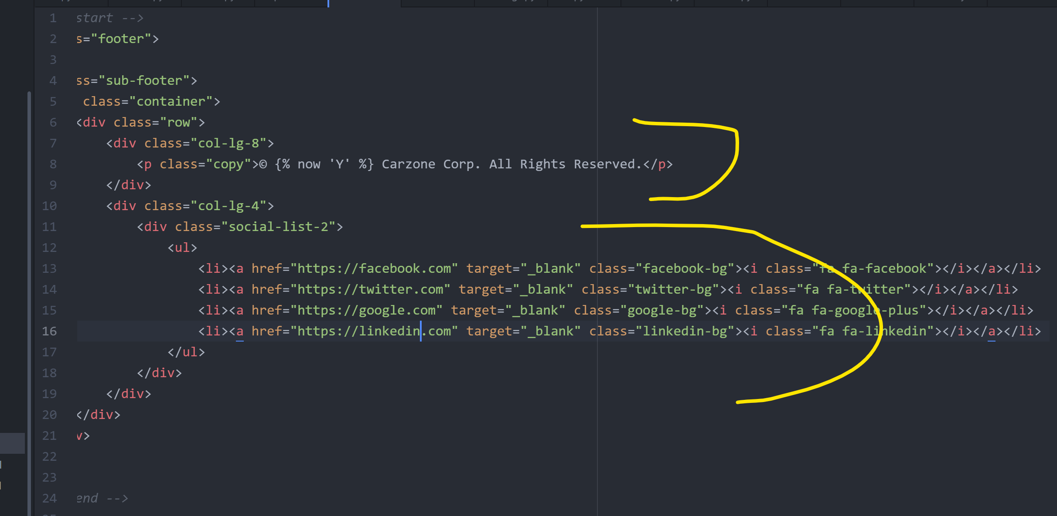

**Changes to footer(Do you have questions)part in Home Page**

Go to home.html

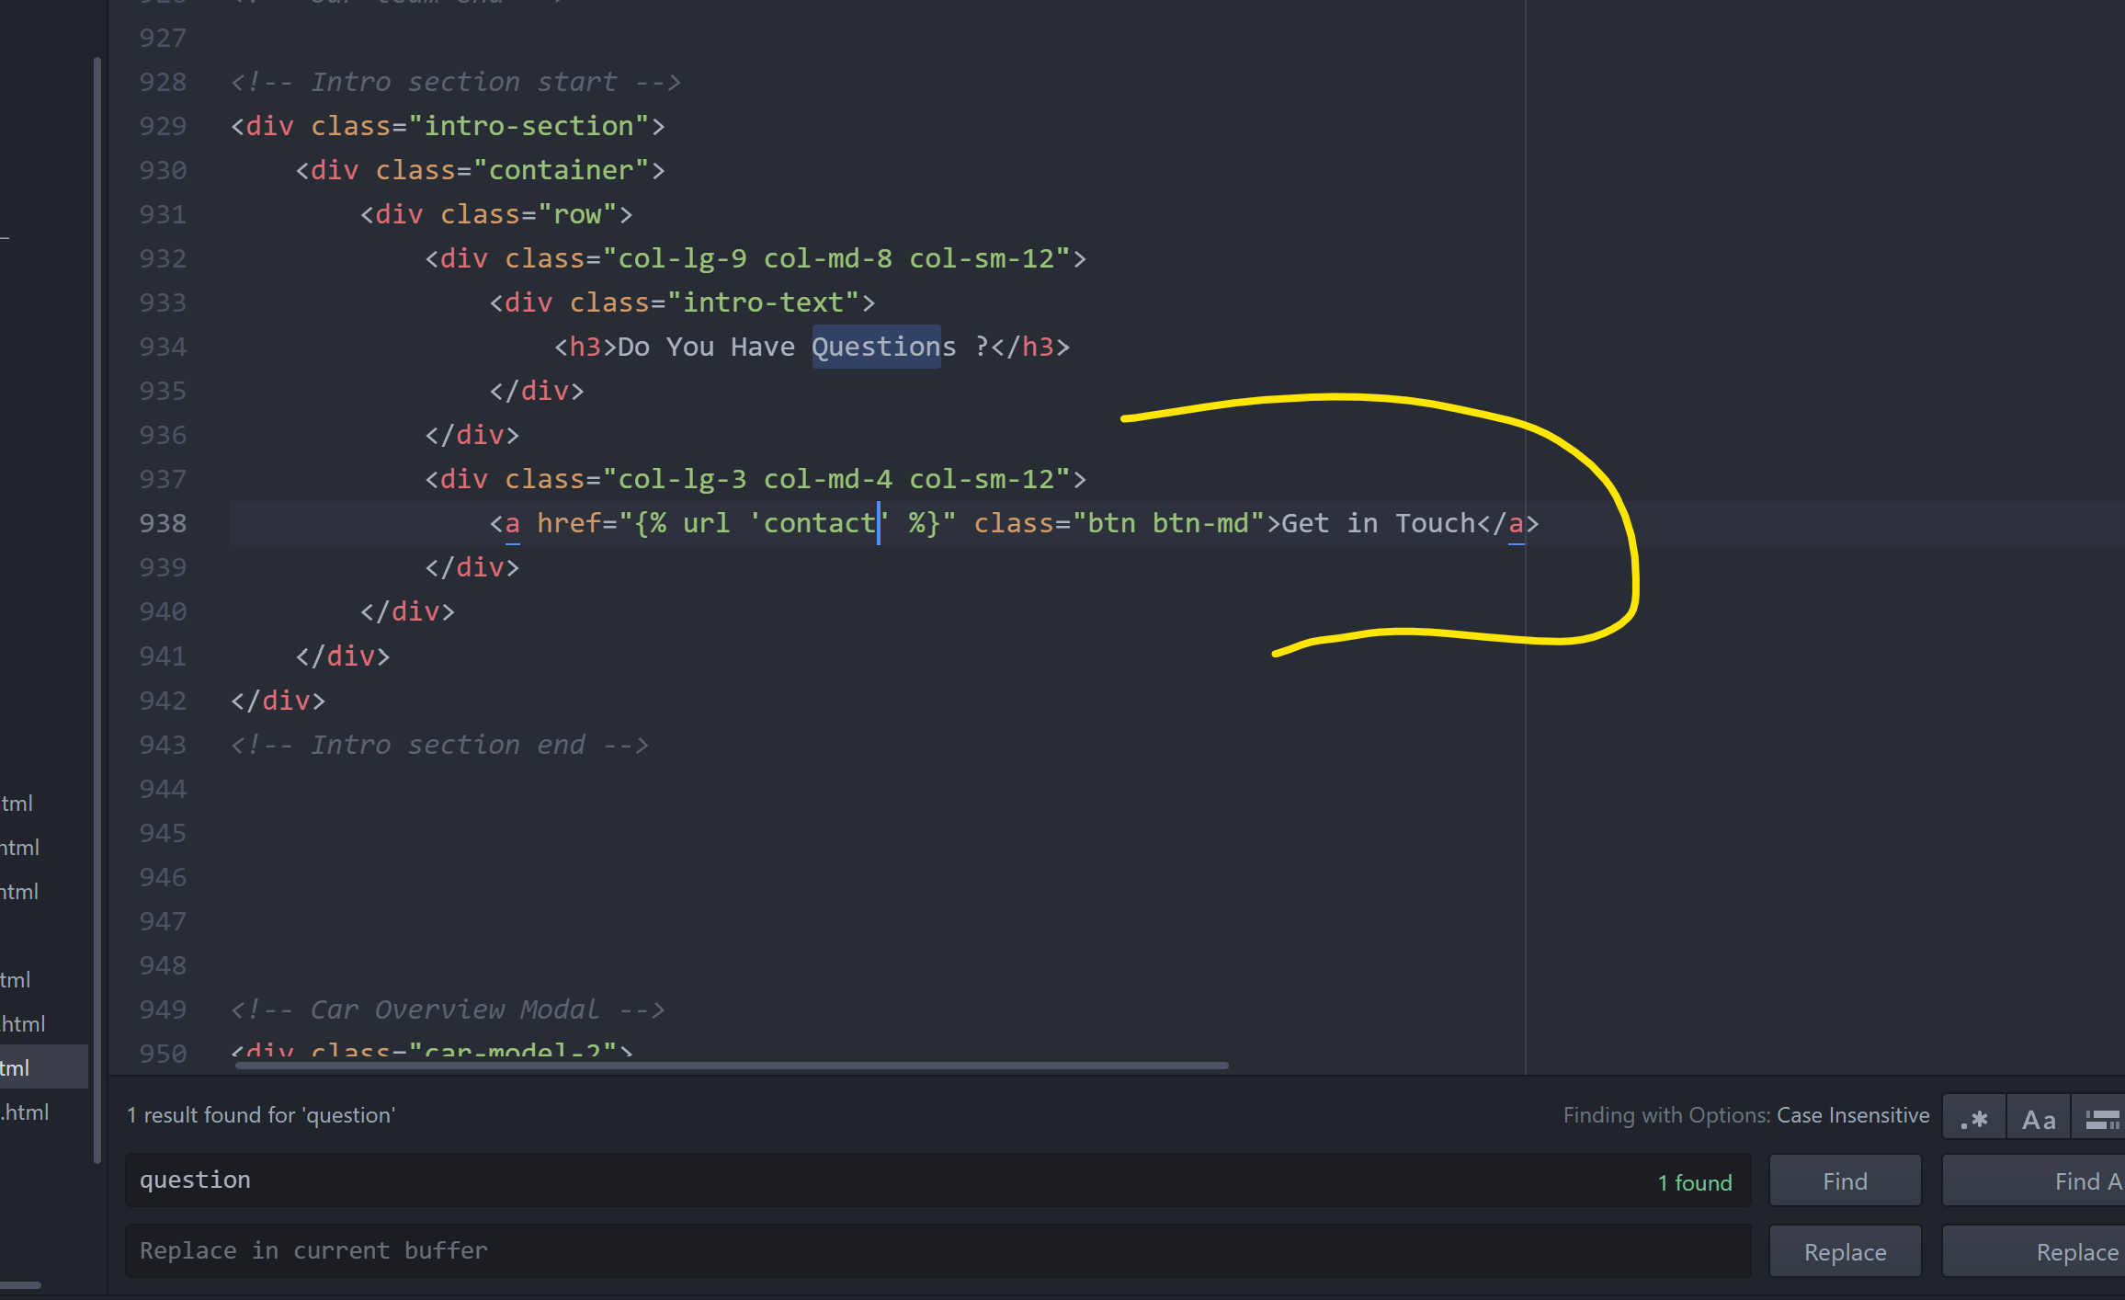

**Making Navbar Links Dynamic(color change of the current visited link)**

Go to navbar.html

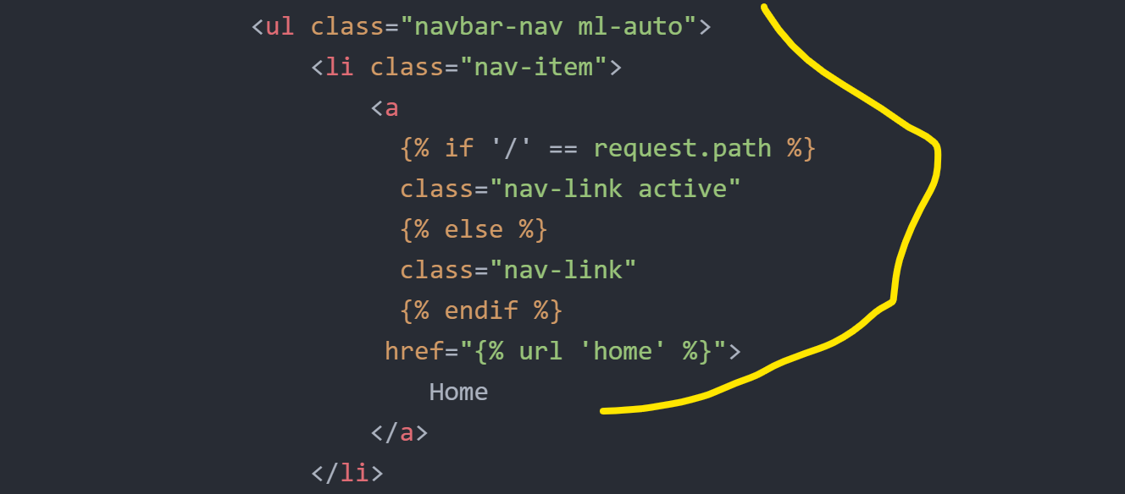

Do same for **About, Services, & Contact**

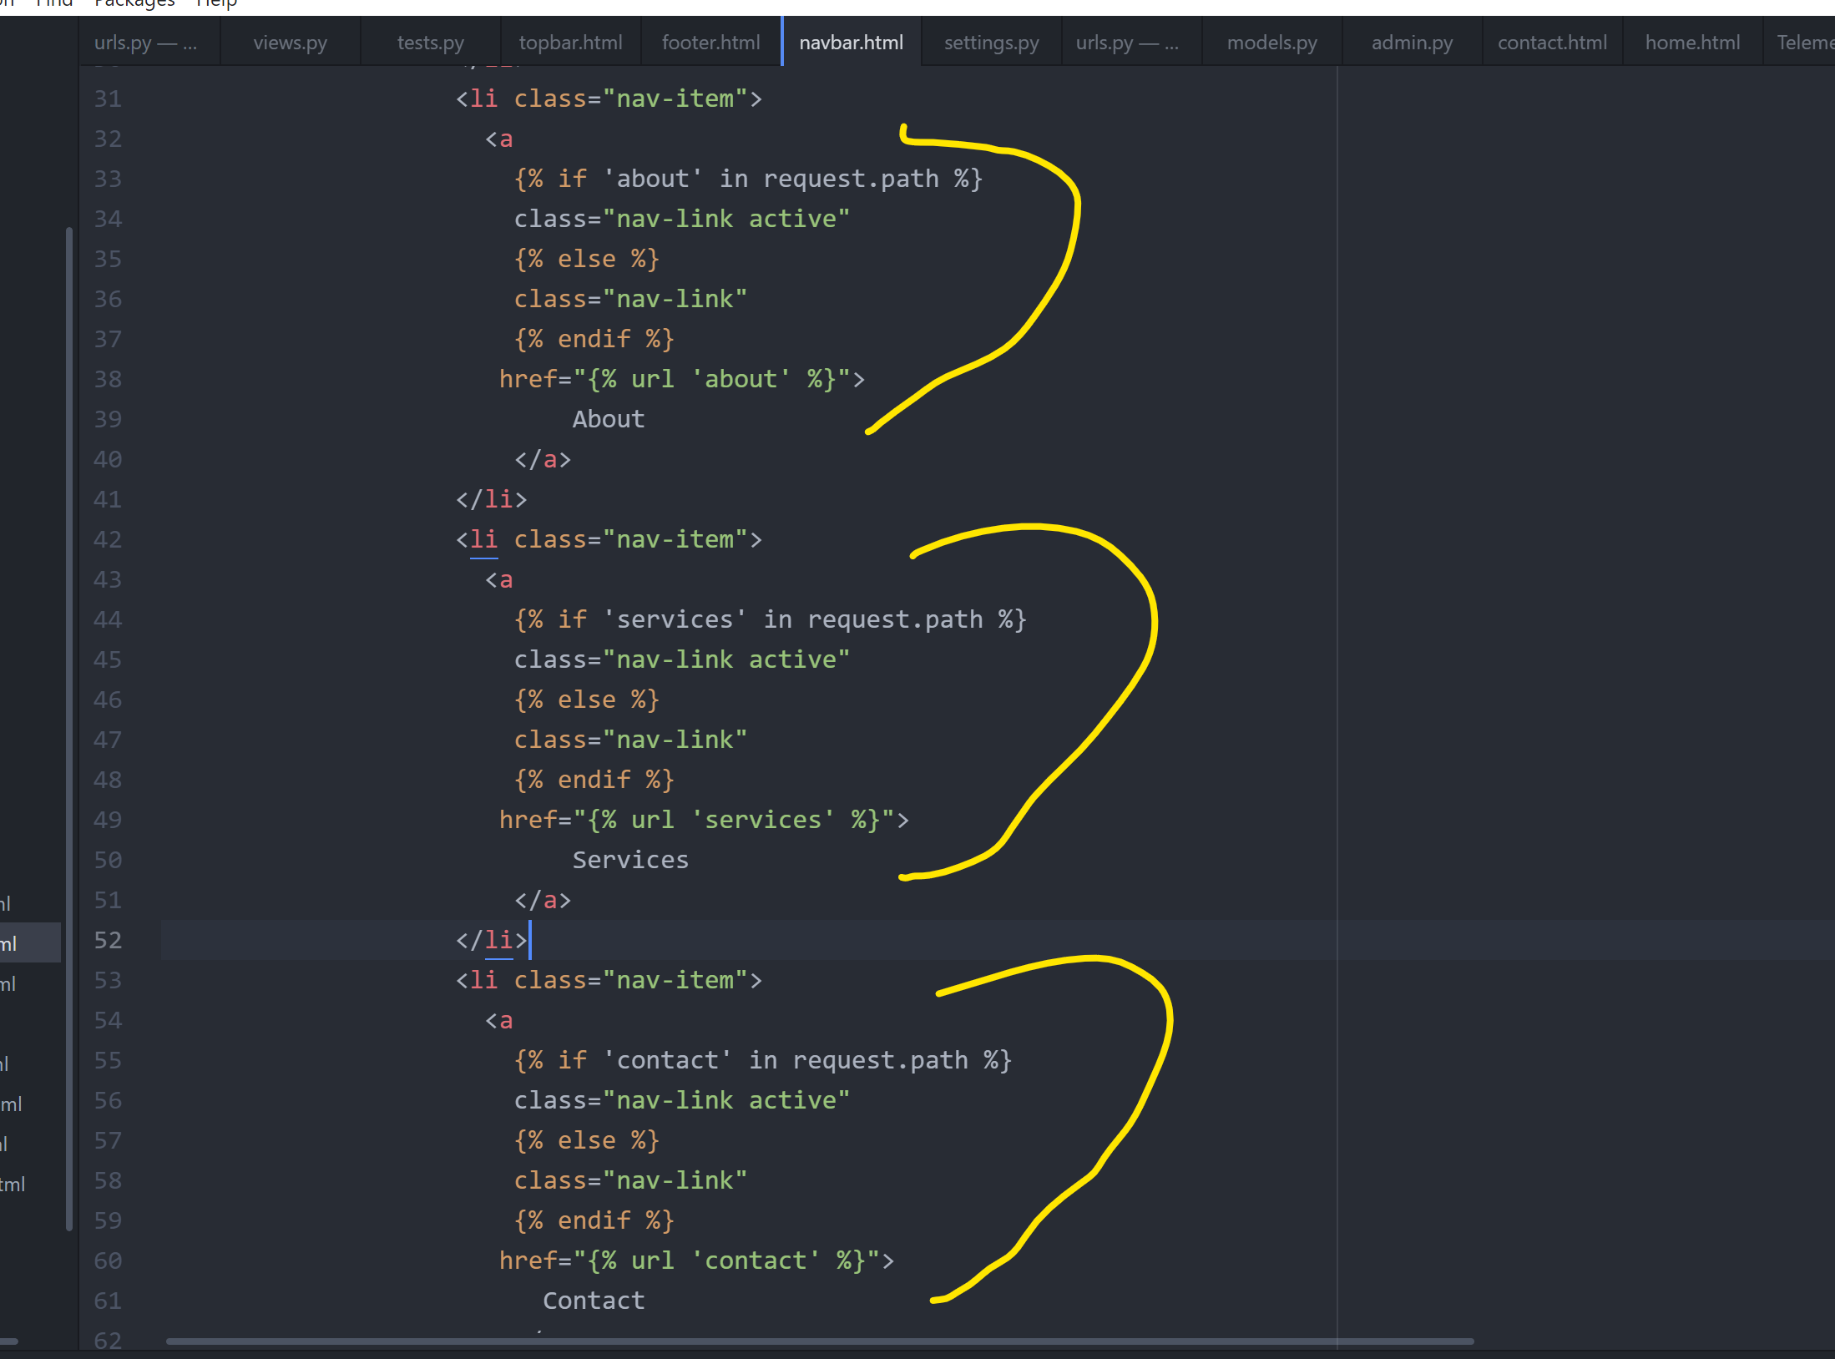

**Read More** link editin **Home Page**

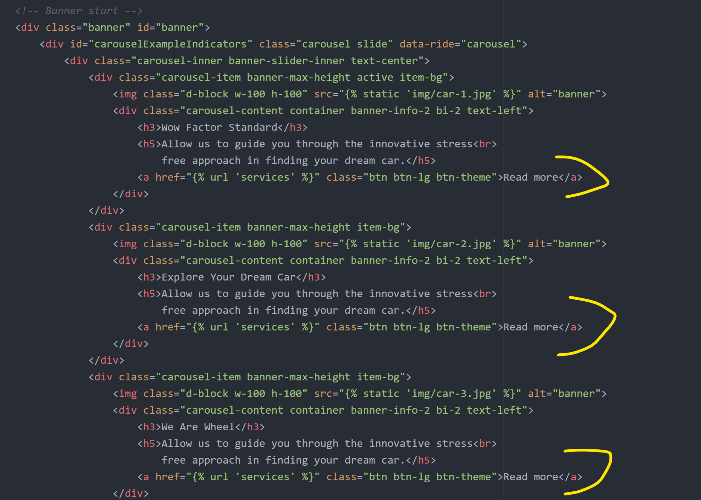

**Creating Cars App**